Improving accessibility and inclusivity of people with disability in a community and mainstream setting.

Latrobe Community Health Service

Table of Contents

About Latrobe Community Health Service 3
About the research 3
Message from the CEO 4
Physical barriers are far more prevalent than they should be in 2020 6
Key findings 6
Improvement opportunities 7
Community attitudes remain a major obstacle to participation for people living with disability 11
Key findings 11
Improvement opportunities 12
Give people with disability the information they need so they can decide whether participation is a real option (before they turn up) 16
Key findings 16
Improvement opportunities 16
Accommodate the growing awareness of, and need for, sensory-friendly experiences 20
Key findings 20
Improvement opportunities 22

About Latrobe Community Health Service
Latrobe Community Health Service is a secular, not-for-profit health service, inspired by a vision of strong, vibrant communities where more people enjoy good health and lead fulfilling lifestyles.
Latrobe Community Health Service began life in the mid-1970s as a group of smaller organisations that provided basic health services from shop fronts and houses throughout the Latrobe Valley, Gippsland.
In 1995 those services merged to form Latrobe Community Health Service.
In the years since we have grown into a multifaceted health provider. We now offer more than 50 services across 50 locations in Victoria and New South Wales.
In Gippsland, our services include allied health, GPs, carer programs, dental and community services.
We provide National Disability Insurance Scheme services in Sydney, Melbourne, and throughout regional Victoria.
Latrobe Community Health Service provides Local Area Coordination in the following areas:

- South Eastern Sydney
- Ovens Murray
- Wimmera South West
- Barwon
- Central Highlands
- Inner Gippsland
- Inner Eastern Melbourne
- Southern Melbourne
- Outer Eastern Melbourne
- Outer Gippsland

We provide Early Childhood Early Intervention support in the following Victorian service areas:
- Central Highlands
- Wimmera South West
Latrobe Community Health Service also owns and operates Link Health and Community®. Link delivers Early Childhood Early Intervention services in the following areas:
- Inner Eastern Melbourne
- Outer Eastern Melbourne
- Southern Melbourne
- Inner Gippsland
- Outer Gippsland

About the research
Latrobe Community Health Service engaged TH?NK Global Research to explore what a day in the life of Australians living with disability looks like in 2020.
Who did we survey?
TH?NK surveyed 600 Australians living with disability, aged between 18 and 65, and their carers.
What disabilities are represented?
Our survey respondents identify as having a physical, sensory, psychiatric, neurological, cognitive and / or intellectual disability. One in five survey respondents also have a chronic medical condition in addition to their disability.
How did we conduct the research?
TH?NK conducted a 10-15 minute online survey that identified the day-to-day activities of people with disability, and the emotional and physical factors involved in those activities. This survey of 600 people complemented three 30-minute, one-on-one interaction mapping sessions that established key pain points.
There are 4.4 million Australians who live with disability. Is this an accurate representation of their lives?
We have allowed for a 5% margin of error in our research findings.

Message from the CEO
As a partner in the community with the National Disability Insurance Scheme (NDIS), Latrobe Community Health Service aspires to empower people with disability to live independent lives in inclusive, accessible communities.
In practical terms, our role involves connecting people with disability, their families and carers to the services and activities that will help them live the life they want to. We also advise service providers, community groups and mainstream organisations on how they can take steps to improve access and be more inclusive of people with disability.
Being inclusive means everyone feels valued and experiences a sense of belonging – regardless of age, ability, gender, nationality, sexuality or religion. Inclusive people and places give people with disability the choice to be involved, and when they decide to participate, they are treated with dignity and respect.
‘Access’ or ‘accessibility’ gives people with disability the right to participate without barriers. This means people with disability can enter and use facilities – like playgrounds, shopping centres, libraries and banks – just as people without disability can. It also means people with disability have the appropriate support to access and fully participate in their community, in healthcare, education, transport and housing.
Most people with disability require support and services to achieve their goals and do the things they enjoy. But even with that support in place, people with disability continue to face two other major barriers: the inaccessibility of the built environment and community stigma towards disability.
Our work gives us an authentic insight into the daily lives of people with disability – every day we hear from them, their families and carers. We set out to expand on these firsthand insights by asking Australians with disability about their day-to-day experiences. What are their most common activities? How do they feel and how are they treated when they are doing those activities? What would they love to do, and what’s stopping them?
Half of the people we surveyed told us they don’t feel included in their community. When we looked further into this, we found the most common activities among the people we surveyed – grocery shopping, using public transport, going to work and eating out – are the least inclusive and accessible. Whereas the least common activities – going to the theatre, museum, bank or aquatic centre – are among the most inclusive and accessible.
We have heard time and time again that people with disability are treated differently; that they can’t do the things they aspire to. This is not because they aren’t capable of doing those things, but because they aren’t given equal access to buildings or they are treated unfairly.
Empowering individuals with disability to live the life they want to, and equipping our communities to be accessible and inclusive, are equally important. You cannot achieve one without the other.
As you read this report you may observe – as we have – that most of our key findings from the research sound familiar. There is a strong through-line connecting our work with the research that precedes it, as people with disability remind the wider community, yet again, of the need for access to built infrastructure and the importance of a community shift in attitudes to disability. It is sobering to realise how much work remains to make our communities truly accessible and inclusive. And it falls on all of us to redouble our efforts.
We therefore present this report for two reasons: to paint a picture of the current lived experiences of Australians with disability, and to suggest tangible changes that will help every Australian live the life of their choosing.
- Ben Leigh
CEO, Latrobe Community Health Service

Physical barriers are far more prevalent than they should be in 2020

Key findings
Almost half (47%) of the people we surveyed had a physical disability. Yet the main barrier preventing them from participating in their community was physical access. When asked what physical factors prevented participation, or made their experience a poor one, time and time again people listed disability car parking, accessible toilets, space for a wheelchair, adaptive equipment and aides.
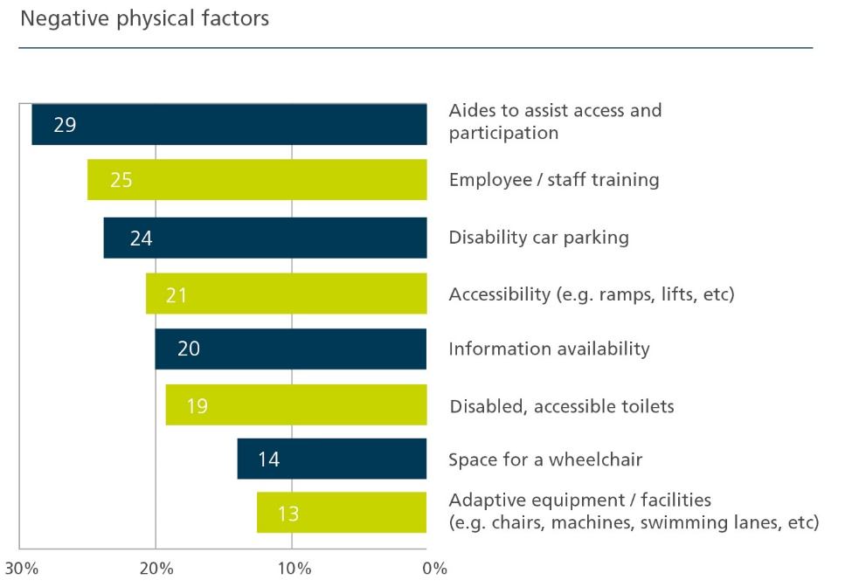
“Some ramps I can’t even turn my chair around on, and they are too steep. It feels like a ‘tick box’ rather than set-up for actual usage.”
What are the implications in practical terms? The things most of us take for granted – like grocery shopping, taking the train, going to work and eating out – are the most difficult for people with disability to do.
Here’s what people told us:
- 70 percent of respondents go grocery shopping, but only a third have a positive experience while doing so
  - “It’s great to have a dedicated time to attend but I don’t think they thought about having enough disability parking spaces during this time.”
  - “Narrow aisles at the supermarket make it really hard to navigate, especially when it’s busy.”
- 47 percent dine at cafes and restaurants, but less than half have a good experience while eating out
  - “I was disappointed because after getting ready and travelling by taxi I found I couldn't access the café because of my disability.”
- 29 percent of respondents work, yet little more than a third are satisfied with their workplace
  - “My office space isn’t so bad, but the access to the toilets is a nightmare.”
- 27 percent use public transport, but less than a third enjoy their commute
  - “I don’t like to use the public transport; the trams are not modern enough for a wheelchair, and those that have the space are not often on my lane.”
The concept of accessible infrastructure isn’t new. For the wider community, wheelchair ramps and car parking spaces near entrances would be common associations with accessibility – even for those who don’t engage with people with disability on a daily basis. Most people understand the importance of wide ramps, elevators, automatic doors and flat and even footpaths – just to name a few – for assisting people in wheelchairs to navigate their way around. There has been campaign after campaign calling for more accessible public transport, shopping centres, libraries and the like. In fact, the provision of ‘dignified and equitable’ access to buildings is written in Australian legislation.
Unsurprisingly, when accessible infrastructure is installed correctly, the experience of people with disability improves. We asked respondents to name the physical factors that helped them access their community more easily. Here’s what they said:
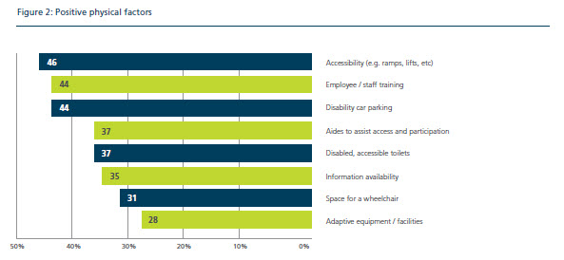
Accessible infrastructure matters, because it can be the difference between a person with a physical disability participating in society or staying home and being isolated.

Improvement opportunities
So, how do we break down physical barriers?
Whether you’re a small business owner, a local council or multinational corporation, there are actions all of us can take.
At a federal, state and territory government level, we recommend the legislation that governs building accessibility standards be simplified.
In 2010, Australia’s inaugural National Disability Strategy was released. This was the first time in the country’s history all governments had committed to a unified, national approach to improving the lives of people with disability, their families and carers. The 10-year strategy was designed to positively shift community attitudes about disability, through the implementation of realistic and practical initiatives.
One such initiative was the implementation of the Disability (Access to Premises — Buildings) Standards 2010, which took effect on 1 May 2011. The strategy described these standards as the means to deliver ‘consistent, systemic and widespread improvements in non-discriminatory access for people with disability to publicly accessible buildings’. Yet from our research, it’s clear people with disability continue to face physical barriers as they go about ordinary, day-to-day activities.
As it stands, Australian building codes and accessibility requirements are complex and changing. When they are not implemented as they should be, the onus is on people with disability to highlight this. Clearly, this is not good enough.
In 2017, the Federal Government agreed to make 21 amendments to the building standards, increase understanding of the legislation through education and training, and implement a consistent way to progress future reform. This followed the standards’ first scheduled review. Given reviews are scheduled every five years, there is opportunity for the government to further simplify the Disability (Access to Premises – Buildings) Standards 2010 when the next review takes place in 2021.
By simplifying the laws that apply to built infrastructure – and applying this set of physical accessibility standards to all buildings (new and old) with fewer exemptions – owners will know what their requirements are, no matter where their building is located or when it was built. The end goal? Physical accessibility becomes an expectation rather than a mere possibility.
In the meantime, we recommend government create financial incentives to increase physical accessibility. The cost of building modifications may deter many owners or landlords from undertaking accessibility works, particularly if they are not obligated to do so under Australia’s current building standards. However, if a grant or subsidy becomes available for owners and landlords to proactively enhance the accessibility of their premises, perhaps we would see fewer barriers in our built environment (and at a much faster rate).
The United Nations Committee on the Rights of Persons with Disabilities recommended Australia’s next National Disability Strategy receive adequate resources, an implementation plan with measurable goals and a robust monitoring mechanism. Consultation and development of the new National Disability Strategy for beyond 2020 is taking shape now. It is the perfect time for the government to consider a subsidy or grant scheme for building modifications that are specifically based on universal and accessible design principles.
In 2010-11, 76 projects across 67 local governments received grants of up to $100,000 as part of a $5 million Accessible Communities initiative that came out of the National Disability Strategy 2010-2020. The initiative aimed to make local buildings and public spaces more accessible for people with disability, with successful projects receiving a matching contribution from the respective local government. Perhaps the next strategy could focus on funding small-to-medium enterprises – those cafes, retailers and gyms that might be willing to improve their accessibility, but simply don’t have the means to conduct accessible building works.
This recommendation is especially timely – as the government seeks to kick-start the economy in a post COVID-19 environment, a national accessibility-focused infrastructure fund could generate employment and fast-track improvements to physical spaces in Australia.
At a local level, all organisations – small or large – should consider completing a self-assessment of the accessibility of their premises. By conducting an audit of your own site, you will quickly ascertain how accessible it truly is for people of all abilities. Don’t know what an accessibility audit looks like? Organisations like the Australian Network on Disability and the Association of Consultants in Access Australia are the experts in this field, and we strongly encourage all businesses, councils and government bodies to seek their advice.
The Australian Network on Disability provides resources, training, programs and consultancy services to help organisations become more accessible and inclusive. Its Access and Inclusion Index is one such offering, which allows organisations to understand and better meet the needs of both employees and customers with disability. Organisations can either do a quick, 10-question assessment for free or become a member of the network to receive a comprehensive self-assessment tool and gain support to build a roadmap of improvement.
The Association of Consultants in Access Australia is the peak body of access consultancy. It exists to advance equity of built environmental accessibility for people with a disability. The association directs the building industry – and owners and managers of premises and facilities seeking expert advice on proper accessibility for people with a disability – to accredited access consultants who can provide that advice and support based on their independent needs.
The Australian Human Rights Commission’s publication Access for all: improving accessibility for consumers with disability is a ‘good practice, good business’ fact sheet with practical tips for businesses, big and small. The Victorian Equal Opportunity and Human Rights Commission has a range of tools and resources to help businesses, employers and organisations meet their responsibilities under the Equal Opportunity Act. The Queensland Government’s Inclusive Tourism: making your business more accessible and inclusive is a guide for tourism operators, local governments and people with disability alike.
In this regard, peak bodies for retail, grocery, manufacturing, local councils and the like have the opportunity to lead the way with their members by pointing them to these resources, encouraging participation or even subsidising the cost.
There are countless bodies across the country – including local disability advocacy networks and community partners of the National Disability Insurance Scheme – that directly support small business owners, healthcare services and community groups. If you want to better understand what physical barriers are preventing people with disability from accessing your premises, contact your local council, NDIS community partner or an accredited access consultant.
What can you do now, even with limited time, resources and money? The social model of disability asserts that people with disability are disabled by the environment they live in, and not by the features of their own bodies. The human rights model of disability acknowledges the goal of enabling people with disability to live independently and be included is about far more than removing mainstream barriers, yet it’s clear many of these mainstream physical barriers still exist. Simple, affordable changes to your shop fitout can be the difference between a person with a wheelchair being able to navigate their way through your premises and not being able to enter it at all. Take the COVID-19 physical distancing measures in cafes, takeaway stores and sports apparel stores. Finally, there is enough space between tables and clothing aisles for a person with a wheelchair (or a parent with a pram, for that matter) to easily move through cafes and shops. We’d encourage businesses and retailers to maintain these measures post COVID-19. Removing these barriers permanently can lead to better access for everyone – not just people with disability.
CASE STUDY: Bank of Melbourne invests in technology, staff training
A small investment has changed the way people with hearing impairments can do their banking.
Portable desktop hearing loops were rolled out in some Bank of Melbourne branches, allowing people who wear hearing aids to interact independently with staff, without needing a quiet space.
A hearing loop is a sound system that cuts out unwanted background noise, so only relevant sound goes directly into a person’s hearing aid.
Bank of Melbourne introduced the system for its Ballarat branch in early 2019 after completing an accessibility self-assessment. With customers making regular use of the device, it was soon made available in a number of other branches.
Bank of Melbourne also rolled out staff training on interacting with people who have complex communication needs, to complement the introduction of the hearing loops.
“For Bank of Melbourne, technology and physical access were a significant part of the approach. But it was just as important to create a culture where people with disability are served in a way that suits their needs,” Bank of Melbourne Regional Executive Brendan Grenfell says.
Find out more at the Bank of Melbourne website.

Community attitudes remain a major obstacle to participation for people living with disability

Key findings
If someone were to ask you what a person with disability needs so they can access their community and participate in activities, what is the first thing that comes to mind? Accessible toilets? Lifts, ramps and automatic doors?
The built environment plays a major factor in enabling participation for people of all abilities. But when we asked survey participants what emotional factors made people with disability feel excluded, stigma about disabilities emerged as a resounding theme.
Here’s what we heard:
“I don’t like to show my feelings as people don’t know how to react and they just stare at me.”
“People often don’t think I’m someone with a disability, so my behaviour makes them feel uncomfortable.”
“Exercising is the best thing I can do for myself both mentally and physically. If I felt the staff understood my disability, I would go to the gym every day.”
“I make an effort to go to the campus to feel more included but I’m always left out of any social activities. It’s like indirect bullying.”
“My stress levels increase every time I go to the bank, as I have to deal with impatient staff, but also with the individuals behind me.”
These experiences paint a clearer picture about why physical barriers remain in 2020, despite years of campaigning. If people don’t care about or understand disability, why would they invest in accessible infrastructure for their business? From these experiences, we can also understand how accessibility doesn’t solely relate to our built environment. People with disability don’t feel like they belong, primarily due to the attitudes of others.
When we asked research respondents what stopped them from going to the movies, eating out, playing sports or doing normal things like grocery shopping, the following themes emerged:
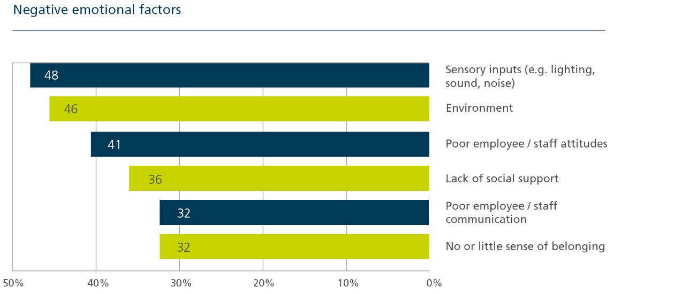
Staff training, employee attitudes, social support and communication are the main emotional barriers people with disability face.
Conversely, respondents said encouraging staff attitudes and good communication paved the way to positive experiences.
Here’s what people told us:
“The staff at the supermarket are always great, I feel like they must get training on how to assist people with a disability.”
“I always go to the same café as they’re really familiar with me, my disability and have patience when I’m having a bad day.”
“One on one swimming lessons have been really positive with an instructor who shows amazing patience and understands my disability.”
Australians would respond better to people with disability if they were trained specifically in understanding, communicating and accommodating disabilities. Likewise, people with disability would feel genuinely included if they felt they were listened to, understood and accommodated for.

Improvement opportunities
So, how do we change community attitudes?
Australia’s National Disability Strategy 2010-2020 recognises ‘people with disability want the same things as everyone else’.
‘Young people with disability have the same aspiration to grow up, get a job and leave home as other young people—and they deserve the same opportunity.’
The strategy also recognises communities that only see deficits in people with disability create barriers to participation and limit their right to leading independent lives.
How can we expect people to remove physical barriers identified in the first part of this report, and for communities to include people with disability, if negative attitudes about disability endure?
The consultation report informing Australia’s next 10-year disability strategy found:
- 53% respondents have experienced improvements in the following areas during the past ﬁve years:
  - accessibility in communities
  - inclusion
  - community attitudes
However:
- More than 80% of respondents said ‘people without disability are unsure how to act toward people with disability’.
- 31% of respondents who have disability believe discrimination has become worse during the past ﬁve years, compared with 29% who said it has become slightly or much better.
- 34% of respondents who have disability reported that experiences of neglect, exploitation, violence and / or abuse had become worse over the past ﬁve years.
We encourage all employers to train their workforce in disability awareness.
This is the first step to changing attitudes. The wider community often gets to hear directly from people with personal, lived experience of disability. They also gain a deeper understanding about how their own attitudes and behaviours may contribute to the barriers people with disability continue to face. Importantly, disability awareness training provides practical tools and tips on how to change reactions, communicate with clarity and empathy, and better include people with disability. Better yet, many training programs and community education sessions are led by people with disability.
Instilling a culture of inclusion affords people their basic human rights. Whether you’re an organisation of 1200 or 10 people, providing fair and equal access – and an environment in which people feel safe and are treated equally – is not only the law under Australia’s Disability Discrimination Act 1992, but put simply, it is the right thing to do.
‘A lack of accessibility creates external barriers that are not a function of a person's disability, but are a function of how well, or poorly, the community interacts with and provides support for that person's life.’
People with disability are not the only beneficiaries when communities are inclusive and accessible. Businesses benefit too.
Missing out: the business case for customer diversity is a 2017 research project by the Australian Human Rights Commission and Deloitte Australia. It found people with disability are three times more likely to avoid an organisation and twice as likely to dissuade others because of that organisation’s negative diversity reputation. When you consider one in five Australians have a disability, organisations that lack accessibility and inclusiveness also risk missing out on a sizeable consumer market.
It’s evident all of us could benefit from undergoing disability awareness education and training. If more of us took up the opportunity, perhaps we would see the barriers people with disability face become fewer and farther between.
Here are some disability awareness training programs available now:
- Let’s Talk Disability – disability awareness workshops delivered at your premises. Visit the Let’s Talk Disability website.
- Disability Aware – informative online course delivered by disability professionals. Visit the Disability Aware webpage.
- Disability Awareness Training – an interactive online course that delivers learnings you can apply at home and in the workplace. Visit the Disability Awareness Training webpage.
Here are some community organisations and projects aimed at enhancing disability awareness and inclusion, led by people with disability:
- Mainstream and Me – people with disability educate local agencies and community organisations about the challenges they face when accessing the community. Visit the Mainstream and Me webpage.
- Belonging Matters – a not-for-profit that provides education, resources and mentoring about social inclusion. Visit the Belonging Matters website.
- People with Disability Australia – a national disability advocacy organisation that provides interactive training on disability access. Visit People with Disability Australia’s website.
- Access and inclusion for businesses – education and training on inclusive communication and disability awareness. Visit the access and inclusion training webpage.
- Women with Disabilities Victoria – the Victorian peak body of women with disabilities that provides training and communities of practice to reduce gender and disability-based discrimination. Visit the Women with Disabilities Victoria website.
- Disability Awareness Training – free online training from the National Disability Coordination Officer Program for people with minimal or no knowledge of disability. Visit the awareness training webpage.
What can you do now, even with limited time, money and resources? We recognise rolling out training modules or organising interactive sessions may not be practical for many small businesses and community groups. There is a plethora of free tools – podcasts, videos and blogs – available. We’d encourage everyone who wants to learn more about disability to hear from people with disability themselves. Get online and download a podcast, watch stories that share the lived experience of people with disability and read up on what people with disability achieve when they’re treated with dignity and respect. This doesn’t involve a lot of time and costs next to nothing – better yet, you may find you learn a little more about yourself as you gain a better understanding of people with disability.
Here are a few of our favourite resources:
- ListenABLE, a podcast that aims to break down stigmas, change perceptions and challenge what you think it’s like to live with disability. Visit the ListenABLE webpage.
- A moment of me, a growing collection of quotes, anecdotes and memories that give a glimpse into the lives of people with disability. Visit ‘A moment of me’ webpage.
- We’ve Got This: Parenting with a Disability, a podcast series that explores the complexities parenting with a disability brings. Visit the podcast’s webpage.
- Carly Findlay, a series of blogs that challenges people’s thinking about what it’s like to have a visibly different appearance. Visit Carly Findlay’s website.
CASE STUDY: Inclusion the focus of Mainstream and Me
People with disability are educating their local communities about inclusive practices and accessible environments and leading local social change initiatives.
Inclusion Australia, the national peak body for intellectual disability, kicked off a 12-month pilot project thanks to a grant from the National Disability Insurance Agency. The ‘Mainstream and Me’ project – aimed at connecting people with disability with mainstream community organisations – saw a team of peer leaders with disability employed to deliver community development, education and training.
The ‘peer community educators’ were based in Victoria, Tasmania, New South Wales and Queensland and delivered workshops across a variety of sectors to break down barriers and assumptions. While funding from NDIA for this work did not continue, many of the leaders that emerged from this project have continued to play a leadership role among their peers through a range of peer support initiatives.
Speak Out Advocacy rolled out the project in Tasmania, where parents with intellectual disability connect with mainstream service providers involved in child protection and family services.
The Council for Intellectual Disability supports the project in New South Wales, where peer community educators reached more than 100 employers and trained more than 50 service employees and 50 people with disability.
VALID supported seven community educators in a project called ‘7 People, 7 Projects & 7 Places’ in Victoria, where peer action groups have been established to develop resources, create networks and develop a range of community inclusion projects.
In Queensland, Parent to Parent showcases the benefits of employing people with disability through presentations delivered by the fully trained peer community educators.
The work has taken a different shape across each state, but a common denominator remains: people with disability are front and centre, working as community development workers and citizen leaders in their local communities.

Give people with disability the information they need so they can decide whether participation is a real option (before they turn up)

Key findings
There are extra considerations people with disability have to make before they go out for the day, join a community group or travel by train. Access to toilets, sensory-friendly environments, support workers, wheelchair access, seats, trained staff and braille signage are just a few.
Consider someone who uses a wheelchair. Before they turn up to a restaurant for a meal, they firstly need to know whether the door to the restaurant is wide enough for their wheelchair. There’s also the consideration of stairs – is there a flat and even entrance to the restaurant? If not, is there ramp access? Then there’s the restaurant floor itself – is there enough space between tables for a wheelchair to navigate through? Is there a wheelchair-accessible toilet?
Pre-planning is a daily reality for people with disability. If they don’t pre-plan, they risk turning up only to find out they can’t actually take part. And yet, information availability (or lack thereof) is a participation barrier for 20% of those surveyed, and contributes to a negative experience overall.
‘When planning an outing, I like to jump on the website and understand what’s there for people with disability, but the information is never accurate. I have to get someone to pre-visit and report back to me.’
When you consider physical access and community attitudes are the primary barriers people with disability face – and they come across these barriers when doing daily or basic tasks like going to the supermarket – it is entirely understandable that people with disability search for information about accessible places and activities before they leave their house.
‘I pre-plan everything I do…’
The information people with disability require should not be difficult to find. Just as we can all find the correct opening hours, contact details and location of most banks, restaurants, cafes and gyms, people with disability should be able to find out whether there is wheelchair access, Auslan interpreters and staff trained in supporting people with communication difficulties. This information is fundamental when determining whether access and participation is a real option.
However, the reality is pre-planning too often becomes a research project.
If this information was publically, universally and easily available, perhaps we would see increased participation from people with disability.

Improvement opportunities
Improving the pre-planning experience for people with disability could in turn increase their participation in the community, in sport and in the workplace. Similarly, it’s likely community sentiment about disability would shift if people with disability were more frequently a part of our daily public lives.
Many government agencies, businesses, recreation and arts centres have taken it upon themselves to provide accessibility information on their websites. Zoos Victoria’s website outlines its universal accessibility approach with a list of options available for visitors who may require additional support. Prospective students of the University of Queensland can find out the support and physical features available to them on the university’s website should they choose to study there. The Australian Department of Health funded the creation of the National Public Toilet Map, which shows where more than 19,000 public and private toilet facilities are located across the country. Information about each toilet is provided, and details opening hours, accessibility details and other features like sharps disposal units and baby change facilities.
There are countless other examples of pre-planning information that is available on websites, whether it be a local council’s mobility map or a shopping centre’s accessible toilets. Yet, this information is not necessarily consistent or up-to-date. Again, the onus is on the person with disability, their family or carer, to research unfamiliar places or experiences to understand whether participation is a real option.
What if there was a universal set of accessibility information every organisation could include on their website?
A universal standard should be established to outline the minimum amount of accessibility detail any organisation should provide on their website. Disability advocacy networks, partners in the community and local councils could then promote this universal standard, encouraging businesses small and large to include this information on an ‘accessibility’ page on their website. Large businesses such as Coles and Woolworths have the opportunity to lead the way by placing this universal set of information – complete with virtual tours, mobility maps and sensory opening hours – on their website. Google could go one step further and add an accessibility tab on the Google My Business page, allowing people to view accessibility features of restaurants, cinemas, libraries and tourist attractions in the same place they find the location, opening hours and contact details.
Ideally, Australians with disability could visit a national, ‘one-stop-shop’ of accessibility details. AccessAble, a UK website and app that ‘takes the chance out of going out’, is the perfect example. Established by Dr Gregory Burke as a result of his own experiences as a wheelchair user and disabled walker, AccessAble provides detailed access guides about thousands of tourist attractions, toilets, shops, restaurants and hotels across the UK. The guide aims to take the anxiety out of leaving the house or visiting venues for the first time, and saves people with disability from having to trawl through websites looking for information about access.
‘If it was as easy as ringing up and asking, we wouldn't be here. We know how important it is to have detailed, accurate information, that's why a trained surveyor visits every venue you will find on AccessAble. Surveyors aren't there to rate a venue or say if they think access is 'good' or 'bad', they are there to collect the facts people have told us are important.’
Australian community organisations, disability services, advocacy networks and people with disability could pool their energy, knowledge and lived experience to create such a resource, potentially drawing on a future grant round through the Australian Government’s Information, Linkages and Capacity Building Program.
What can you do now, with limited time, money and resources? Consider what support or physical features you provide customers and employees with disability – include this information on your social media page and website if you have one. Do you provide disability car parking spaces? Is your site wheelchair accessible? Are your staff trained in disability awareness? If so, advertise this! Reach out to your local disability advocacy network and peak organisations, like the Australian Network on Disability, for information about how you can accurately promote your accessibility features. Let people with disability know they are welcome, and include them when they turn up.
CASE STUDY: Website showcases accessible places across Bendigo
A website that showcases accessible places across the greater Bendigo region has taken the guesswork out of planning a day out.
People with disability, their families and carers can visit the Inclusive Towns website and fill in relevant search fields to find a pub with accessible toilets or a shopping centre with wheelchair access.
Likewise, businesses, employers and tourism operators can visit the same website for steps they can take to become more inclusive.
The Inclusive Towns Project is made up of people with a lived experience of disability who can also advise local businesses on inclusion in four areas: communication, physical access, employment and disability awareness. It has been designed to roll out in any area across regional, rural and metropolitan Australia, with local councils encouraged to seek advice and resources directly from the project team.
The Inclusive Towns Project is a partnership program between the City of Greater Bendigo, Loddon Shire and Mount Alexander Shire and was funded in 2018 by the National Disability Insurance Agency.
Find out more at the Inclusive Towns website.

CASE STUDY: Providing the key to access for people with invisible disability
Colour photographs, supportive text, maps, visual communication boards and sensory guides can help prepare people with invisible disability for unfamiliar places and experiences.
This information is not always available or that easy to find, and so Access Ability Australia has teamed up with the likes of Vision Australia to produce ‘access keys’.
Access keys describe the sensory elements, as well as access details like parking and toilets, of various venues and attractions across Melbourne.
The resources are free to download and available in a full colour PDF or text only document, as well as in audio and Braille formats.
Access Ability Australia works directly with venues to ensure the access keys are accurate and up-to-date.
Find out more at Access Ability Australia’s website.

Accommodate the growing awareness of, and need for, sensory-friendly experiences

Key findings
People with autism can be oversensitive or undersensitive to noise, light, clothing or temperature, meaning their senses – sight, hearing, touch, smell and taste – take in either too much or too little information from the environment around them. While there are strategies people with autism can put in place to cope with their sensitivities, they are often forced to avoid crowded places or unpredictable environments where they will likely face sensory overload.
Almost a quarter of research respondents identify as having autism, making it the most common disability among the people we surveyed. And sensory-overloaded environments (think sound, smell and light) were a major contributor to negative emotional experiences. In fact, sensory inputs – like bright or flashing lights, crowded places and loud music – were the main emotional barrier stopping our respondents from participating in their community.
‘People are becoming more aware of the physical signs of autism, but for me it’s more about the environment. The lights are always too bright.’
We asked respondents to rate their overall experience when conducting common activities, like going to the supermarket or seeing a movie at the local cinema. Libraries, museums, galleries and community hubs have a lot to teach the rest of society about how we can all include people with disability.
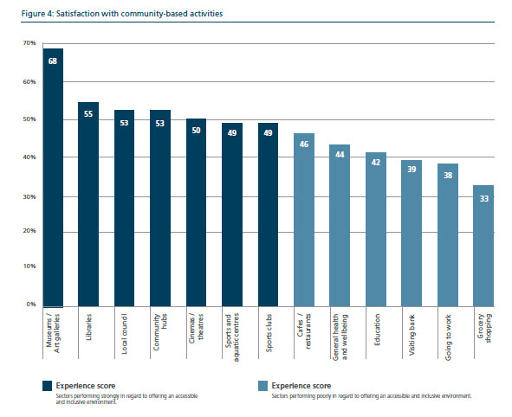
Research respondents with autism participated in the following activities more than people with any other disability.
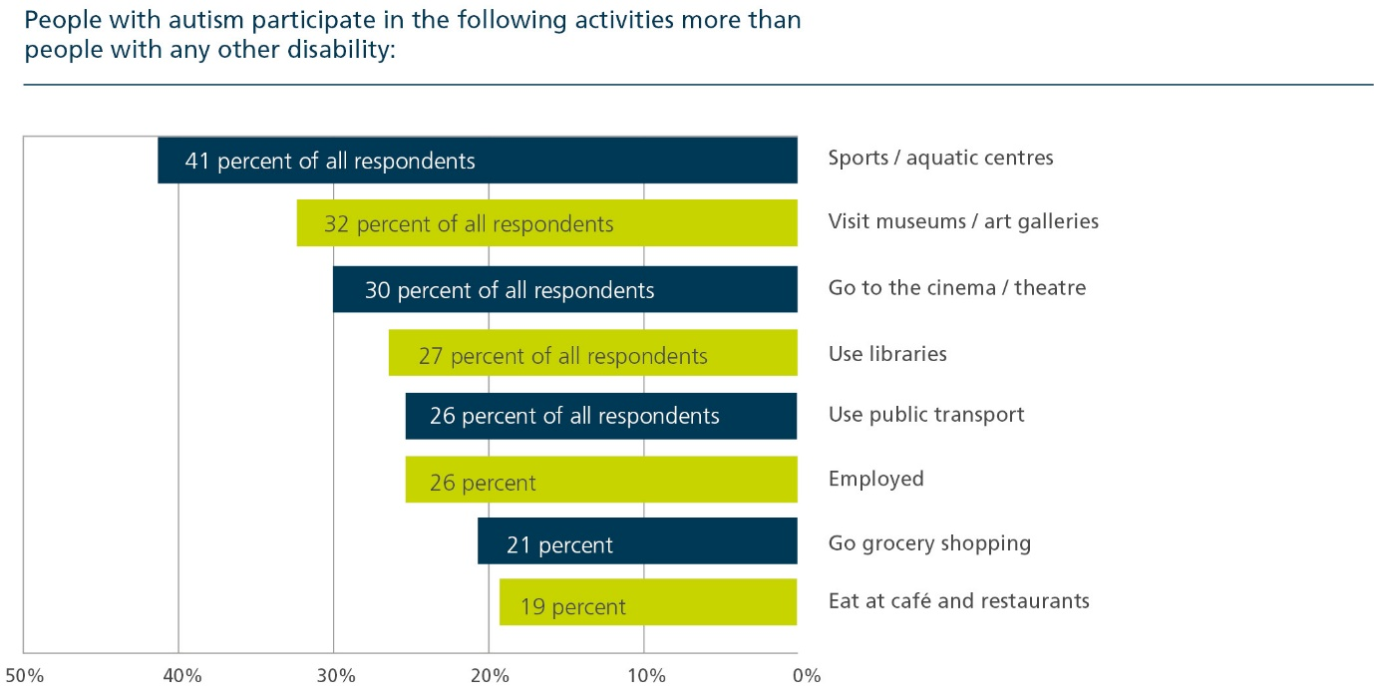
It’s unsurprising, then, that when we asked respondents what could improve their experience, the introduction of sensory-friendly experiences, dedicated calm areas and quiet hours were suggested again and again.
‘I like that they (the local libraries) have a special sensory day for those living with a disability. This is what all businesses should be doing to support us.’

Improvement opportunities
We recommend businesses, councils and services provide sensory-friendly experiences as a standard feature.
Autism Awareness Australia estimates there are more than 1.2 million Australians who have a deep, personal connection to invisible disabilities, such as autism and developmental delay. In comparison, there are less than 200,000 Australians who use wheelchairs, or 350,000 if you include their carers.
‘…invisible disability [is] a huge, overlooked customer segment, with very distinct needs and substantial purchasing power.’
Meeting the needs of people with autism – by offering sensory-friendly hours, the ability to pre-plan through the provision of social stories or scripts and inclusive communication – is good for business. In contrast, Missing out: the business case for customer diversity has found customers with disability are three times more likely to actively avoid places that have poor reputations for diversity.
We’d encourage everyone looking to offer sensory experiences to first seek guidance from the experts.
In Australia, there are organisations that represent the autism community and can directly support businesses, councils, sports centres and service providers to become more inclusive.
Autism Awareness Australia has an ‘InvisAbility’ arm that helps organisations understand how inclusive their customer experience really is and how they can improve. InvisAbility offers self-assessments, online training, face-to-face communications workshops and templates – all of which are designed to help you deliver consistently inclusive customer experiences.
Victorian organisations can become ‘inclusive champions’ when they seek the expertise of the state’s peak body for people with autism. Amaze supports organisations to become pillars of best-practice accessibility for people with autism, and access the untapped market of more than 55,000 Victorians who have autism. From training in autism awareness to environmental audits, cost-effective quiet spaces and the creation of story-based tools – Amaze gives organisations the backing and guidance to become autism-friendly.
Don’t forget to involve people with autism in the planning, design and implementation process.
People with disability have told governments loud and clear: ‘Nothing about us, without us.’
If you want to offer a truly inclusive experience for people with autism, include them from the start. Set up a working group consisting of local people who have autism, carers of people with autism and autism networks. Contact your local autism network to get started. Visit the Autism Community website for your local network. Work on a roadmap together to improve your inclusive offering. Co-design your sensory-friendly experience, quiet spaces / hours and pre-planning resources. Ask people with autism to pilot your solution, and take on their feedback to continuously improve. Ensure your sensory-friendly service or quiet hour is truly fit-for-purpose.
What can you do now, with limited time, money and resources? Educate yourself on how people with autism and other conditions with sensory sensitivities experience the world. Amaze’s ‘Do One Thing For Autism’ is a great resource for individuals, workplaces and education settings – and it’s free. Visit the Do One Thing For Autism website. Share awareness-raising campaigns like Change Your Reactions. Visit the Change Your Reactions website. Get involved in events like AUStism, a speaker series from Autism Awareness Australia that presents stories from people with autism.
Consider how your behaviour can impact on someone who has autism, and the people who love them. Remind yourself people experience noise, light, sound, smells and social situations differently to you. Don’t expect others to respond to situations exactly as you do. Challenge the people around you to understand autism. Change your perspective and in turn, you’ll change your reaction.
CASE STUDY: All abilities access available at Ballarat Aquatic and Lifestyle Centre
A leisure centre in the heart of regional Victoria offers more than your standard fitness experience.
The Ballarat Aquatic and Lifestyle Centre kicked off 2020 by launching sensory quiet times and sensory-friendly programs across its centre.
Sensory quiet periods reduce anxiety and sensory stress for people who value quieter, less stimulating environments. Aside from dimming the lights, turning down the radio and encouraging other patrons to keep noise to a minimum for a set period, the centre has also introduced sensory balance play, water playgroup and private swimming lessons for people with sensory sensitivities.
“Our team takes pride in the accessibility of our centre,” BALC Centre Manager Gerald Dixon says.
“We’re always on the lookout for initiatives that will improve the centre and our programs to meet the needs of all members of the community.”
The sensory quiet times were developed with feedback from, and in consultation with, members and users of the Ballarat Aquatic and Lifestyle Centre, as well as the Central Highlands NDIS Local Area Coordination Service, Sports Central and the Ballarat Autism Network.
“We work closely with our key stakeholders to increase accessibility to the centre and the independence and confidence of people of all abilities,” Mr Dixon says.
“We know sensory-friendly environments are essential to many people with an autism spectrum disorder and their families, and we’re delighted to provide regular sensory quiet timeslots for our patrons.”
Lights are dimmed, music and announcements turned off (unless there’s an emergency) and signage placed at the front desk 10 minutes before each sensory quiet session begins. Patrons can attend a gymnastics class, aquatic lesson or have a casual swim in a quiet environment, with two sensory-friendly group change rooms available during this time.
As part of its inclusive approach, the centre also ensures customers have consistent swimming teachers and gymnastic coaches wherever possible. Processes are in place to alert customers if there are last-minute changes due to illness or emergency.
“We’ve implemented a weekly staff catch-up to share learnings from these inclusive initiatives and discuss opportunities to improve,” Mr Dixon says.
“Feedback from staff and our customers is crucial – this will inform the future look of our sensory quiet times and other accessible features at the centre.”

CASE STUDY: Game day a sensory experience for Geelong sports fans
Noise cancelling headphones, fidget toys and a safe space to avoid the crowds are free features of a major sports stadium in Geelong.
In an Australian first, AFL, A-League, Big Bash League and all major events at the GMHBA Stadium are accredited as sensory inclusive.
The Kardinia Park Stadium Trust and Geelong Football Club partnered with US non-profit KultureCity to provide an accommodating and welcoming experience for sports fans who live with sensory sensitivities.
Fans can now turn up on game day, borrow a sensory bag with headphones, fidget toys and other resources. Lap mats are also available to borrow and patrons can use the stadium’s sensory zone at any stage during the event – a dedicated quiet space with a multi-sensory room.
To prepare for the experience, they can also visit the stadium’s sensory zone before the game, take a ‘virtual tour’ online or personalise a social story to get a sense of what they might see and hear on the day.
The initiative – which took nearly two years to become a reality – involved a number of community groups and adds to the stadium’s other accessible features.
Find out more at the Kardinia Park website.

Disability (Access to Premises — Buildings) Standards 2010: https://www.legislation.gov.au/Details/F2011C00214
National Disability Strategy 2010-2020: https://www.dss.gov.au/our-responsibilities/disability-and-carers/publications-articles/policy-research/national-disability-strategy-2010-2020
2016 Review of the Disability (Access to Premised – Buildings) Standards 2010 (Premises Standards): https://www.industry.gov.au/data-and-publications/2016-review-of-the-disability-access-to-premises-buildings-standards-2010-premises-standards
Committee on the Rights of Persons with Disabilities, Concluding observations on the combined second and third periodic reports of Australia: https://tbinternet.ohchr.org/_layouts/15/treatybodyexternal/Download.aspx?symbolno=CRPD%2fC%2fAUS%2fCO%2f2-3&Lang=en
Including People with Disability in Community Life – Accessible Communities Fact Sheet: https://www.dss.gov.au/our-responsibilities/disability-and-carers/program-services/for-service-providers/accessible-communities/including-people-with-disability-in-community-life-accessible-communities-fact-sheet?HTML
National Disability Strategy 2010-2020, p18: https://www.dss.gov.au/our-responsibilities/disability-and-carers/publications-articles/policy-research/national-disability-strategy-2010-2020
Right to opportunity: Consultation report to help shape the next national disability strategy: https://www.dss.gov.au/disability-and-carers-a-new-national-disability-strategy-reports/right-to-opportunity-consultation-report-to-help-shape-the-next-national-disability-strategy-summary-report
Delivery of outcomes under the National Disability Strategy 2010-2020 to build inclusive and accessible communities, Chapter 1: https://www.aph.gov.au/Parliamentary_Business/Committees/Senate/Community_Affairs/AccessibleCommunities/Report/c01
Missing out: The business case for customer diversity (2017): https://humanrights.gov.au/our-work/rights-and-freedoms/publications/missing-out-business-case-customer-diversity-2017
Australian Bureau of Statistics’ Disability, Ageing and Carers, Australia: Summary of Findings: https://www.abs.gov.au/ausstats/abs@.nsf/0/C258C88A7AA5A87ECA2568A9001393E8
AccessAble: https://www.accessable.co.uk/pages/about-accessibility-guides
Individual Capacity Building Program 2020-21: https://www.communitygrants.gov.au/node/1221
Autism Awareness Australia: Facts for decision makers: https://www.autismawareness.com.au/invisability/facts-for-decision-makers/
Autism Awareness Australia: Facts for decision makers: https://www.autismawareness.com.au/invisability/facts-for-decision-makers/
Missing out: The business case for customer diversity (2017): https://humanrights.gov.au/our-work/rights-and-freedoms/publications/missing-out-business-case-customer-diversity-2017
Right to opportunity: Consultation report to help shape the next national disability strategy: https://www.dss.gov.au/disability-and-carers-a-new-national-disability-strategy-reports/right-to-opportunity-consultation-report-to-help-shape-the-next-national-disability-strategy-summary-report

