How to register on the 10,000 Steps website
Go to the 10,000 Steps website at www.10000steps.org.au
Please note: If you have previously registered with 10,000 Steps, you don’t need to re-register.
Step 1. Click on the ‘Sign Up’ button
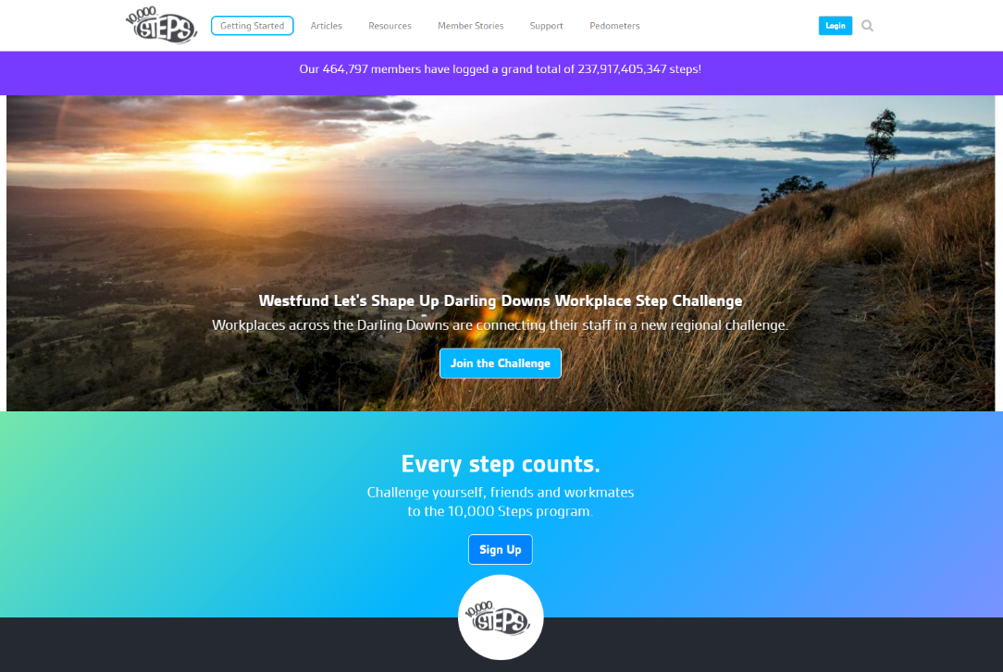
Step 2. Fill in your personal details and select ‘next’
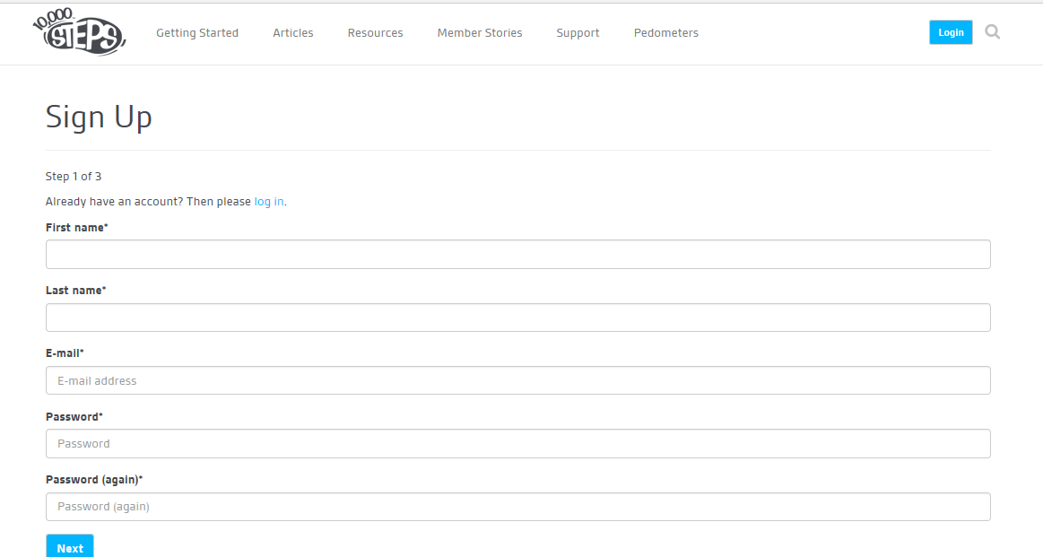

Step 3. Continue to enter your details and select your preferences. Select ‘next’.
Step 4. Select that you would like to register as a Participant.
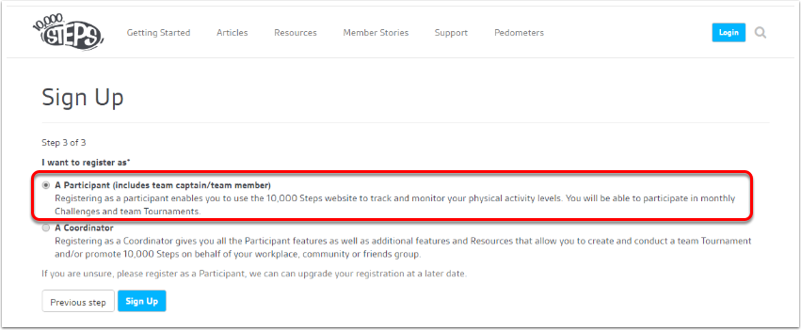
Step 5. Verify your email address.
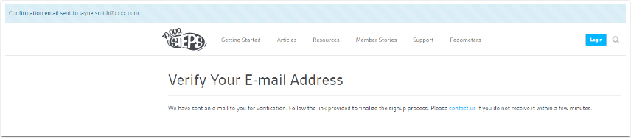

You are now registered on the 10,000 Steps website.

As soon as all teams are finalised, your workplace coordinator will pass your team details onto the LCHS challenge organisers, who will enter your team into the Latrobe 10,000 Steps Challenge. If you have let us know you don’t have a team and still want to participate, we will allocate you to our challenge and find a team for you.
Step 6. Download the 10,000 Steps app, available on iOS and Android devices

