

LATROBE HEALTHY SUPERMARKETS PROJECT
EVALUATION
June 2023

FEDERATION UNIVERSITY
COLLABORATIVE EVALUATION & RESEARCH CENTRE

SUPPORTING INNOVATIVE RESEARCH AND EVALUATION

LATROBE HEALTHY SUPERMARKETS PROJECT EVALUATION

DRAFT
26/02/2026

ACKNOWLEDGEMENTS
__________________________________________________________________________________

The Collaborative Evaluation and Research Centre (CERC) Federation University Gippsland, acknowledges Aboriginal and Torres Strait Islander people as the traditional owners and custodians of the land, sea and nations and pay our respect to elders, past, present and emerging. The CERC further acknowledges our commitment to working respectfully to honour their ongoing cultural and spiritual connections to this country.

The CERC would like to acknowledge the Latrobe Health Innovation Zone (LHIZ) for funding the development of the Centre and for its ongoing support.

The CERC would like to thank Latrobe Community Health Service (LCHS) and the Latrobe Health Assembly (LHA) for their contribution and support. Further we would like to thank Deakin University students who took part in this evaluation.

ABOUT THE AUTHOR

The Collaborative Evaluation and Research Centre (CERC) Federation University Gippsland is an innovative initiative that aims to build evaluation capacity and expertise within Gippsland. As a local provider the CERC understands the value of listening to the community and has the ability to deliver timely and sustainable evaluations that are tailored to the needs of a wide variety of organisations.

Professor Joanne Porter is the Director of the CERC. Joanne has led a number of successful research projects and evaluations in conjunction with local industry partners. She has guided the development of the CERC since its formation in 2018.

The team that evaluated the Latrobe Healthy Supermarkets Project include:

- Professor Joanne Porter

- Valerie Prokopiv
- Dr Vaughan Reimers
- Elissa Dabkowski
- Dr Daria Soldatenko
- Kaye Borgelt

Professor Joanne Porter

Table of Contents
ACKNOWLEDGEMENTS 4
ABOUT THE AUTHOR 4
1. EXECUTIVE SUMMARY 6
1.1 INTRODUCTION 6
1.2 KEY FINDINGS AND IMPLICATIONS 6
1.3 RECOMMENDATIONS 7
2. INTRODUCTION: LATROBE HEALTHY SUPERMARKETS 11
2.1 INTRODUCTION 11
2.2 PROJECT DELIVERY 11
3.THE EVALUATION OF LATROBE HEALTHY SUPERMARKETS 14
3.1 AIM OF THE EVALUATION 14
3.2 EVALUATION RESEARCH QUESTIONS 14
3.3 DATA COLLECTION / TOOLS USED 15
4. EVALUATION FINDINGS 15
4.1 PRE-INTERVENTION CUSTOMER SURVEY 15
4.2 POST-IMPLEMENTATION SURVEY FINDINGS 21
4.3 MONASH UNIVERSITY STORE SCOUT 38
IGA 1 40
IGA 2 41
IGA 3 43
Comparative Store Data 44
Limitations of Store Scout App 44
4.4 INTERVIEWS WITH STORE MANAGERS 45
4.5 STAKEHOLDER FOCUS GROUP 45
5. DISCUSSION AND RECOMMENDATIONS 48
5.1 DISCUSSION 48
5.2 RECOMMENDATIONS 50
6. LIMITATIONS 50
7. ETHICAL APPROVAL AND PRACTICE 50
8. ABBREVIATIONS 51
9. LIST OF FIGURES AND TABLES 52
10. APPENDICES 54
10.1 CUSTOMER INTERVIEWS 54
10.2 HUMAN RESEARCH AND ETHICS APPROVAL 56

1. EXECUTIVE SUMMARY

1.1 INTRODUCTION
Obesity and poor diets have been linked to many chronic diseases and decreased life expectancy. 73.3% of adults living in Gippsland, which includes Latrobe City, are considered overweight and obese. This is the highest percentage of the five Primary Health Network regions in Victoria, and above the Australian average of 67.0%. Almost 32% of adults living in Latrobe City are categorised as obese (BMI≥30), significantly higher than the Victorian average of 21.3%.
Just 5.9% of Victorian adults meet the recommended minimum daily intake for vegetables, while 43.1% meet the recommended daily intake for fruit. When all dietary factors are considered together – overweight and obesity, dietary risks and high blood plasma glucose – the combined burden of disease is 20.4%, making these dietary factors the single greatest contributor to the disease burden in Australia.
The Latrobe Community Health Service (LCHS), Latrobe Health Assembly (LHA) and participating supermarkets worked in partnership on the flagship Healthy Supermarkets Project named Reach for the Stars. Reach for the Stars was a promotional campaign designed to assist supermarket shoppers to find healthy food options.
An eight-week trial was held from August – October 2022 at IGA supermarkets in Morwell, Glengarry and Moe, displaying a variety of promotional messages in-store designed to encourage healthy food options. The Collaborative Evaluation & Research Centre (CERC) worked in partnership with LCHS and LHA to evaluate the project.

1.2 KEY FINDINGS AND IMPLICATIONS
- Consumers have a good awareness of the Health Star Rating system. At the conclusion of the Reach for the Stars implementation 72.0% (n=54) of customers reported that they were familiar with the Health Star Rating system, 74.2% (n=46) reported knowing about the Health Star Rating system prior to the intervention.
- 66.7% of respondents when prompted noticed at least one Reach for the Stars promotion in store, with Health Star Rating shelf tags the most common.
- One in four (24.0%) customers, unprompted, noticed materials encouraging healthy food options.
- 41% of customers noted that campaign materials had a positive impact on thinking about buying healthy options, with one in three (31%) customers going on to report that they were more likely to buy healthy food options because of seeing Reach for the Stars promotional material.
- Customers were most likely to recall seeing Health Star Rating shelf tags, also fruit and vegetable banners and posters and healthy recipes.
- Almost six in ten (54.7%) of customers reported they find it easy to know which foods are the healthiest when shopping, with 41.4% going on to report that they always buy the healthiest products available.
- Participants were slightly less likely to check the Health Star Rating after the trial (56.7%, n=63) than before (67.8%, n=63). A similar result was achieved when asked whether the Health Star Rating influenced buying habits, with 69.9% (n=65) indicating it did prior to the trial and 57.6% (n=64) after the conclusion of the trial.
- When asked to identify foods with a high Health Star Rating (4.5 or 5) more than 80% of participants were able to correctly identify a carrot and banana and 62% identified wholegrain cereal. Results were similar pre and post intervention.
- A significant majority (86.5%) of customers believe that supermarkets should continue to encourage healthy eating by providing discounts on healthy foods, showcasing healthy options at the end of aisles, and having more shelf space for healthy options.
- The Monash University Store Scout mobile application which assesses healthiness of a food retail environment demonstrated an average improvement of 3.7% across the three sites, with breads and cereals (12%) and fruit and vegetables (11.1%) showing the most positive improvement.
- Ten customers who completed a survey agreed to be interviewed as part of the project evaluation. These consumers identified the most important things when purchasing food were price and brand.
- Nine of the ten interviewees were aware of Health Star Rating, however, only two participants stated that it would influence their purchase. Most participants were more likely to review ingredients to decide if it was healthy “…I always look at the ingredients, how much salt, fats and sugars, I don’t take much notice of a star rating…”
- Client surveys conducted before and after the Reach for the Stars project did not demonstrate a statistically significant change in shopping behaviour. Potentially this could be due to an already high level of participants’ prior awareness of the Health Star rating system and awareness of healthy shopping behaviours.
- Interviews with key stakeholders identified that collaboration was the key to the success of the Reach for the Stars project and that the project has the potential to make an important contribution to public health, particularly from a health equity perspective.
- Store managers were invited to participate in individual interviews to share their insights, however, all declined the offer. Therefore, it is not possible to make any comment regarding whether the Reach for the Stars project impacted business outcomes.

1.3 RECOMMENDATIONS
- The campaign is worthy of continuing as it influences customer thinking about healthier foods.
  - A longer and broader campaign is needed to establish a sustainable change in customer behaviour.
  - Visibility of Reach for the Stars materials remains present.
- Change the Health Star Rating threshold to 4 stars and above which will decrease confusion for consumers and include more ‘core’ food products including pastas, breads, and eggs.
- The co-design process should include store managers and all staff to ensure they support the concept of the campaign.
  - Encourage customers to help design resources, recipes, and promotional items to ensure the campaign is relatable to the target population.
  - Provide opportunities for enhancement of the intervention phase which may include incentives.
- Explore other healthy retail strategies such as ensuring healthy options are within consumer’s price range and promoting branding highlighting Australian grown produce.
- Incentivise supermarkets to participate in future healthy options campaigns.
- Measuring impact of the Reach for the Stars intervention requires a longitudinal methodology which incorporates the ability to extract store data of individual items.
  - A targeted approach to extraction of store data with the focus on fresh fruit and vegetables and easily identifiable items in the store data codes.

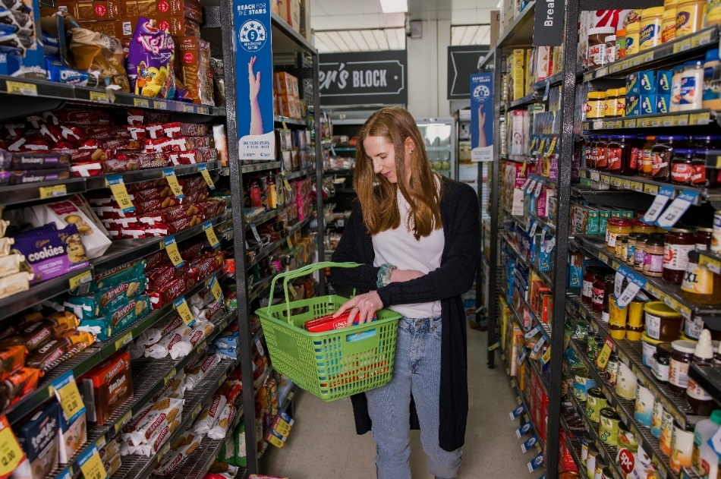
Image: Campaign promotional image
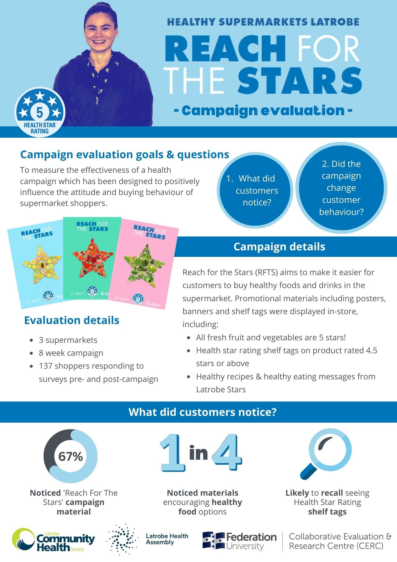
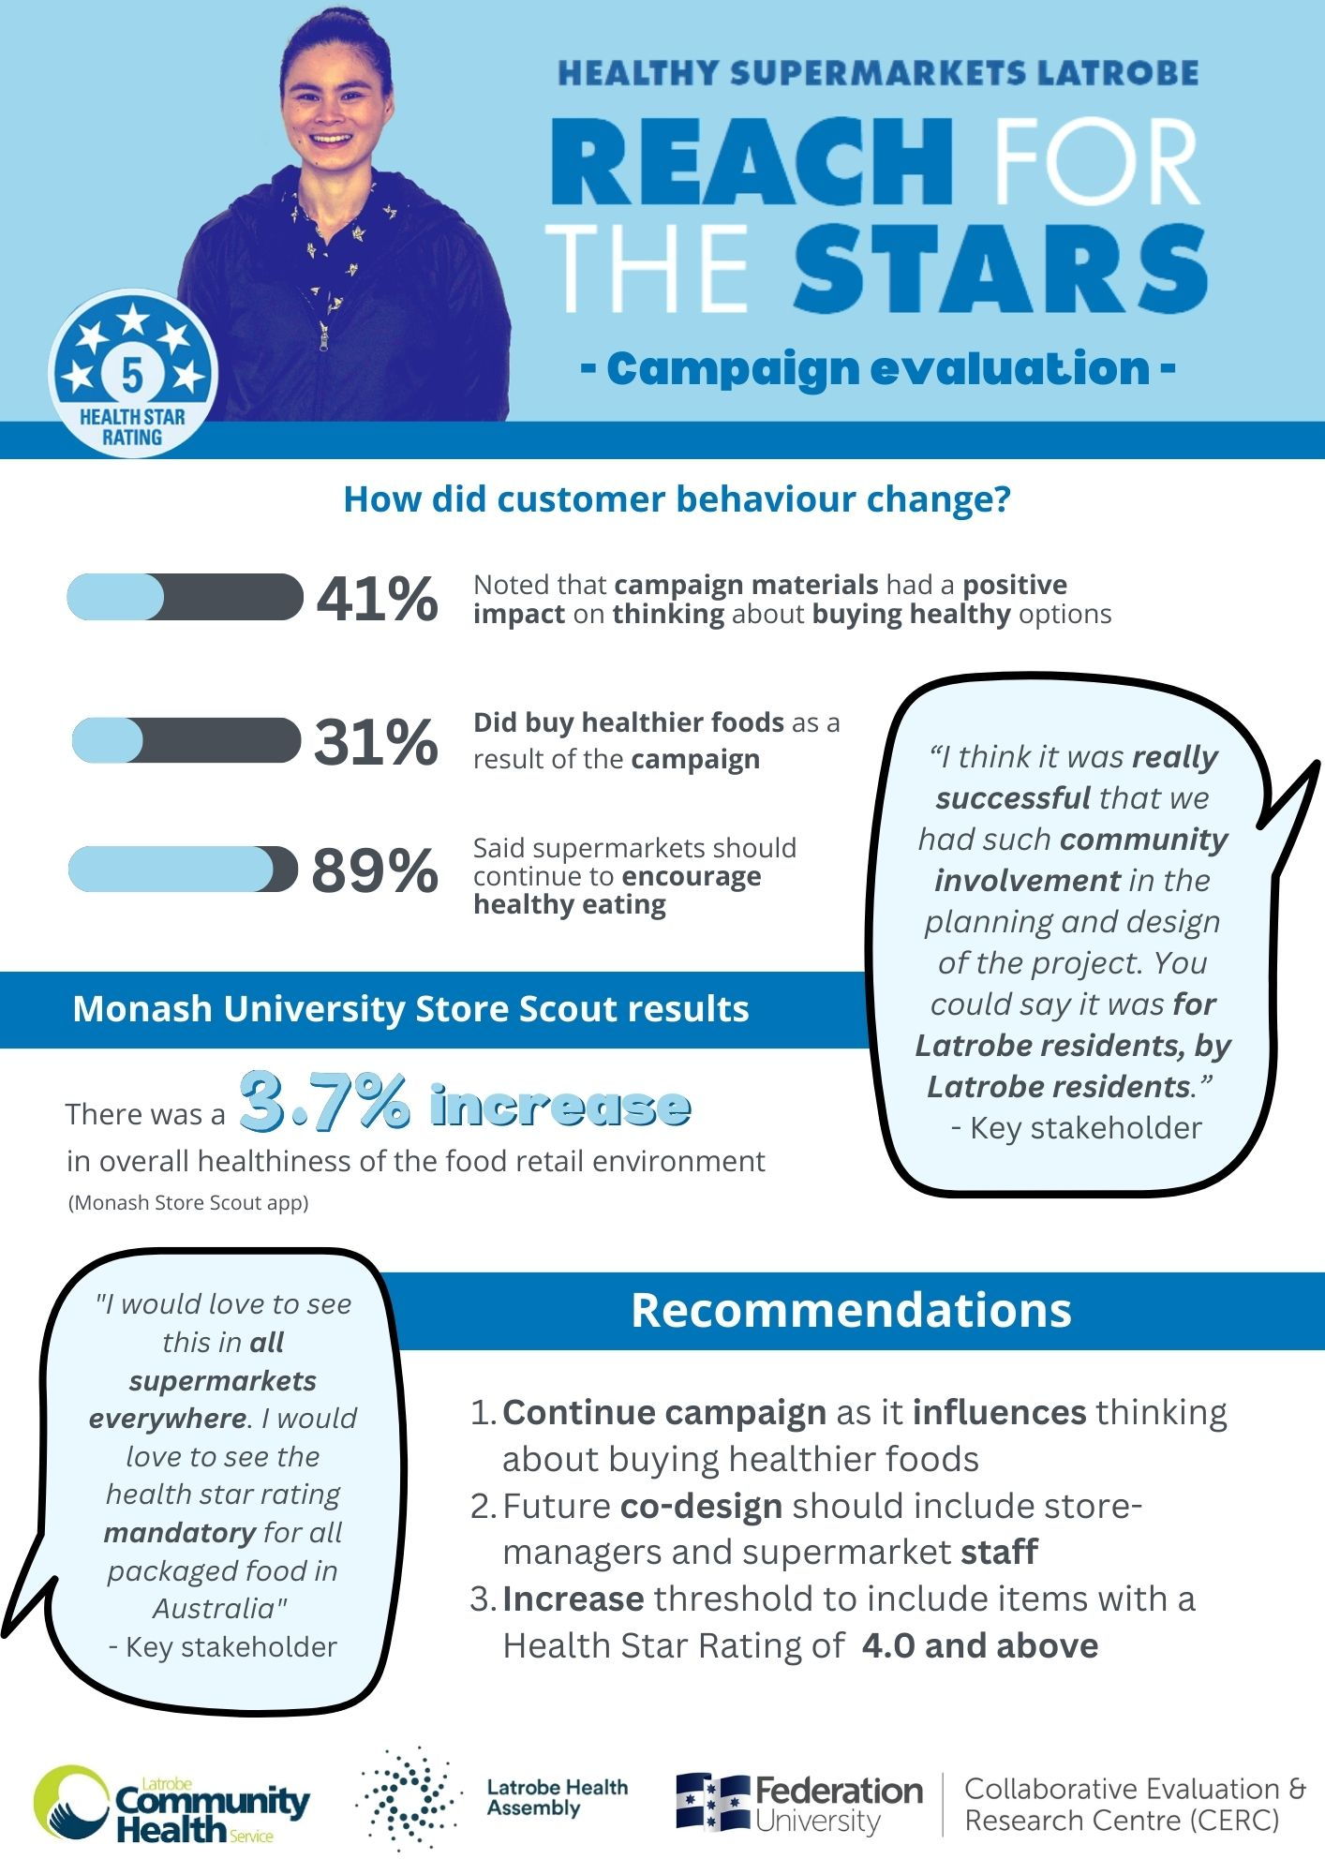

2. INTRODUCTION: LATROBE HEALTHY SUPERMARKETS

2.1 INTRODUCTION
The Latrobe Community Health Service (LCHS), Latrobe Health Assembly (LHA) and participating supermarkets worked in partnership on the flagship Healthy Supermarkets Project named Reach for the Stars. Reach of the Stars was a promotional campaign designed to assist supermarket shoppers to find healthy food options. The project was co-designed with community members and inspired by the successful Eat Well @ IGA Bendigo project.
The goal of the project is to increase healthy eating (particularly consumption of fruits and vegetables) by increasing promotion of healthy foods and drinks in the supermarket.
The objectives of the project are:
- To increase promotion of healthy foods (and drinks) in participating supermarkets.
- To increase purchasing of healthy foods in participating supermarkets.
- To increase customers’ awareness and understanding of the Health Star Rating (HSR) system.
- To increase customers’ confidence to purchase healthy foods in the supermarket.
- To increase efficacy of supermarket owners and staff in promotion of healthy foods.
Reach for the Stars uses a range of interventions based on the Australian Dietary Guidelines and Health Star Rating system. The Health Star Rating system is an interpretive front-of-pack labelling system that rates overall nutritional information of packaged foods and assigns a rating from ½ star to 5 stars. The higher the rating, the healthier the product.
An eight-week trial of the Reach for the Stars ran during August – October 2022 at IGA supermarkets in Morwell, Glengarry and Moe, displaying a variety of promotional messages in-store including store posters, shelf labels, messaging on staff uniforms and shopping trolley signage, designed to encourage healthier food options. The partnership worked with supermarkets and the community to co-design the campaign. Data was collected from Churchill initially, however, the store later declined to participate in the program.
The CERC has worked in partnership with LCHS and LHA to evaluate the project. The CERC developed tools to measure the impact of the initiatives in collaboration with the project partners. The tools included a customer survey, supermarket staff survey, interview questions for supermarket management staff and members of the project team and an analysis of Monash University’s Store Scout food retail healthiness assessment tool.

2.2 PROJECT DELIVERY
Making use of marketing and promotional techniques in stores, Reach for the Stars utilised a number of strategies to promote healthy foods and drinks, and encourage consumers to purchase products with high Health Star Ratings. Interventions included the following marketing materials:
- Posters – ‘All fresh fruit and veg are 5 stars!’
- Health Star Rating shelf tags
- Healthy eating messages from ‘Latrobe Stars’
- Other healthy eating messages
- Healthy recipes
- Local messages from ‘Latrobe Stars’. The ‘Latrobe Stars’ were local residents sharing how they shop, cook and eat healthy foods.
The project was co-designed with project partners, supermarket retailers and community members. Community members were integral throughout, being involved in the control group, working in focus groups to establish the marketing materials most appropriate for Latrobe communities, and fronting the ‘Latrobe Stars’ part of the campaign sharing how they shop, cook, and eat healthy foods every day. All supermarkets in Latrobe were approached to participate in the project, with only independent retailers, IGA and FoodWorks, indicating an interest. Healthy retail strategies ultimately chosen for implementation were evidence-based, feasible to implement, acceptable to supermarket retailers and Latrobe community.
Deakin University students on industry placement at LCHS were tasked with undertaking assessments of the healthiness of the food retail environment using the Monash University Store Scout Application. Assessments were undertaken before (baseline) and during (post) the Reach for the Stars implementation, and at larger stores as a benchmarking comparison. Students also assisted to install resources in the supermarkets. In-store marketing materials were monitored weekly to ensure compliance and fidelity.
Pre and post implementation surveys were conducted as exit surveys at participating supermarkets. Although the low number of responses meant it was difficult to draw conclusions.
A social marketing campaign and communication plan complimented the strategy and included promotion of the project and increasing awareness of the Health Star Rating system through a press release, social media, radio advertising, outdoor advertising, activation events and a website.
Pictured below is a selection of the campaign materials used.

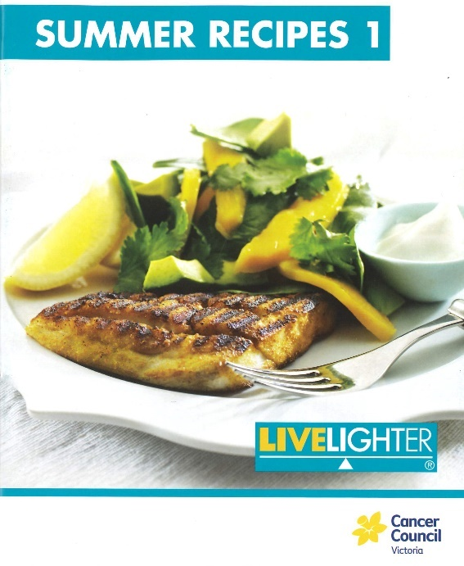
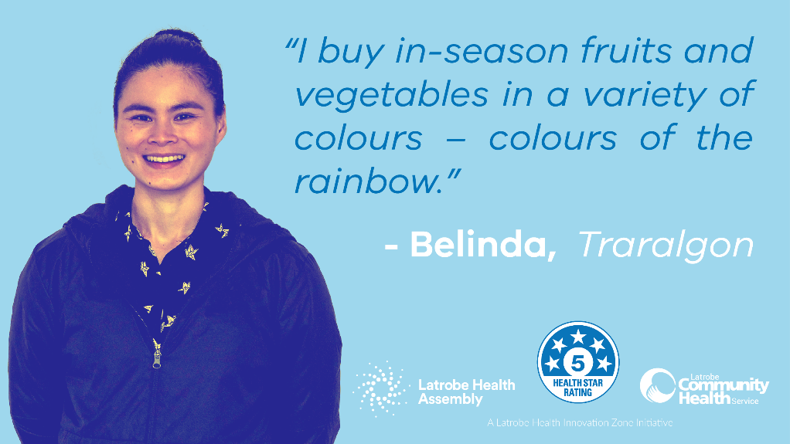
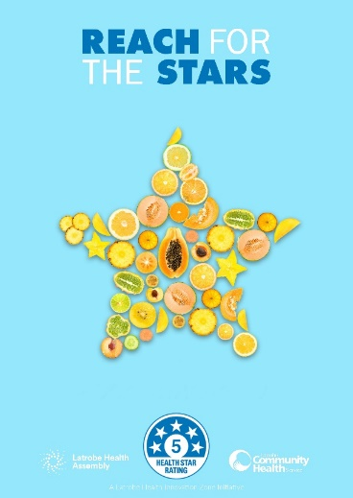
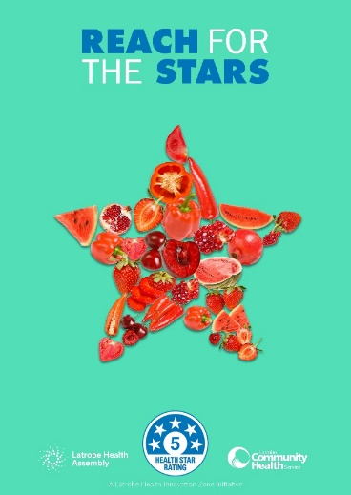
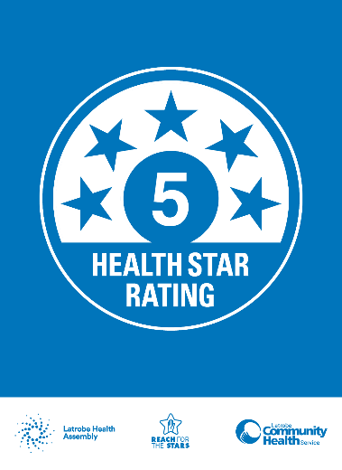
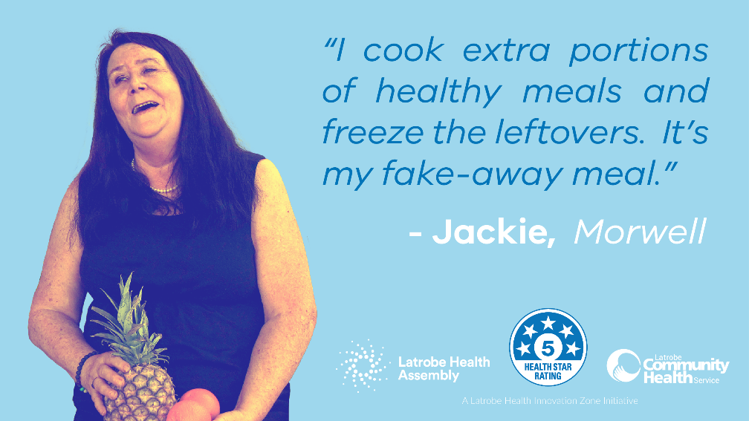
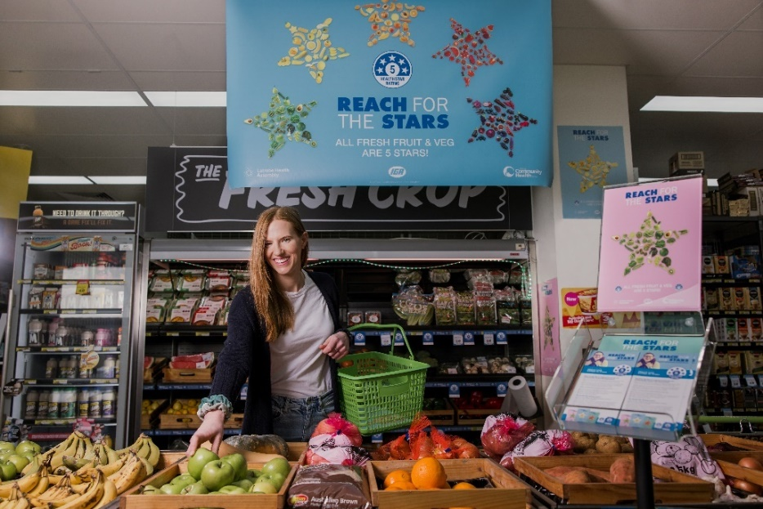

3.THE EVALUATION OF LATROBE HEALTHY SUPERMARKETS

3.1 AIM OF THE EVALUATION
The goal of the project is to increase healthy eating (particularly consumption of fruits and vegetables) by increasing promotion of healthy foods and drinks in the supermarket.
The objectives of the project are:
- To increase promotion of healthy foods (and drinks) in participating supermarkets.
- To increase purchasing of healthy foods in participating supermarkets.
- To increase customers’ awareness and understanding of the Health Star Rating (HSR) system.
- To increase customers’ confidence to purchase healthy foods in the supermarket.
- To increase efficacy of supermarket owners and staff in promotion of healthy foods.
The evaluation seeks to measure the effectiveness of the health campaign which has been designed to positively influence the attitude and buying behaviour of supermarket shoppers, and to gain insight into the perceptions of stakeholders who played a key role in delivering the campaign.

3.2 EVALUATION RESEARCH QUESTIONS
The key research questions surrounding shoppers are:
- Did shoppers notice the campaign messaging?
- If so, what elements of it (e.g. posters, shelf labels, etc.) did they notice?
- Did these campaign elements change the way they think or feel towards healthier eating?
- Did these campaign elements change actual behaviour (as measured by the increased purchase of healthier foods)?

The proposed evaluation strategy comprised of both a demand-side (e.g. the shopper) and a supply-side perspective (e.g. supermarket managers and staff). The key research questions are:
- What insights can staff, and managers provide into the success and impact of the Campaign?
- What perceived benefits were there to the supermarket in participating in the Campaign?
- Would the supermarket participate in such a Campaign if it were to run again in the future? If so, what aspects of the Campaign worked well, and what aspects could be improved?
- What other strategies might supermarkets use to encourage healthier diets amongst their customer base?

The evaluation aimed to also include an analysis of the business outcomes of the interventions, however, this was not able to be achieved due to lack of engagement with store managers.

3.3 DATA COLLECTION / TOOLS USED
The evaluation of the project utilised a variety of data collection tools in a mixed methods approach which provided information about the process, outcomes, and impact. Quantitative and qualitative data was collected as shown in Figure1 below.

Figure 1: Data Collected

4. EVALUATION FINDINGS

4.1 PRE-INTERVENTION CUSTOMER SURVEY
INTRODUCTION
A random sample of 62 participants completed a pre-intervention survey at IGA stores in Morwell, Glengarry and Moe in August 2022. The largest number of participants were shoppers from Moe (51.6%, n=32) (Figure 2).

Figure 2. Number of particpants from each store
DEMOGRAPHIC INFORMATION
The majority of participants were female (69.4%, n=43), and 29.0% (n=18) were male. One participant did not state their gender. All participants were aged over 18 years with a high proportion of consumers aged over 65 years (33.9%, n=21), The number of participants for each age category is shown in Figure 3 below. Almost all participants (95.1%, n=58) do most of the grocery shopping for their households.

Figure 3. Age range of participants

GROCERY OPTIONS AND SHOPPING PATTERNS
Participants were asked about the importance of various features of grocery items when choosing what to buy. As shown in Figure 4, “the brand name” was not important for just over half of the participants (54.8%, n=34) when shopping. Most participants (85.5%, n= 53) said that “how it tastes” was highly important. “How healthy it is” and “How much it costs” were also perceived as highly important (62.9%, n=39 equally).

Figure 4. Importance of various features when purchasing grocery items
Participants were given a series of six statements related to their grocery options and asked to rate each one from Strongly Agree to Strongly Disagree. For the purposes of reporting, Strongly Agree and Agree data were combined and labelled as Agree, and Strongly Disagree and Disagree data were combined and labelled as Disagree. The results are shown in Figure 5 below.
Statements |  | Responses
I know which food or drink to buy based on my own knowledge. | Number and precentage of participants
Before buying any food or drink, I look to see if there is any health messaging on the product (e.g., “good source of vitamins and minerals” or “no added sugar”). | Number and  precentage of  participants
Before buying any food or drink, I always look at the health star rating. | Number and precentage of participants
Before buying any food or drink, I check the ingredients and nutrition information on the back of the pack | Number and  precentage of  participants
I always choose the healthiest products available when shopping | Number and  precentage of participants
I find it easy to know which foods are the healthiest when shopping | Number and  precentage of participants

Figure 5. Shopping patterns

The majority of participants (82.3%, n=51) relied on personal knowledge when shopping. In addition, a significant proportion of participants (66.1%, n=41) found it easy to know which foods were the healthiest. More than half of the participants (54.8%, n=34) reported that they always chose the healthiest products available. Two out of every five participants agreed they looked at ingredient and nutrition information and Health Star Ratings when looking at food options.

HEALTH STAR RATING SYSTEM
Participants were asked about their knowledge and behaviours related to the Health Star Rating system. They were asked if they were familiar with the Health Star Rating information on packaged foods. Of the 58 participants who responded, 79.3% (n=46) said “Yes” while 12 (20.7%) did not know about it. In response to the question “How often do you check the Health Star Rating of a product?”, “Sometimes” (27.4%, n=17) and “Often” (25.8%, n=16) were the most common responses (Figure 6). A small percentage (9.7%, n=6) “always” checked the Health Star Rating. Ten participants (16.1%) did not respond to this question.

Figure 6: Frequency of checking Health Star Ratings
Participants were asked how often the Health Star Rating influences what they buy. Although there was no one option chosen by the majority of participants, 39 participants (62.9%) reported a medium-to-high impact through choosing the options of “Sometimes” and “Often” (Figure 7).

Figure 7: Frequency of purchasing due to Health Star Ratings
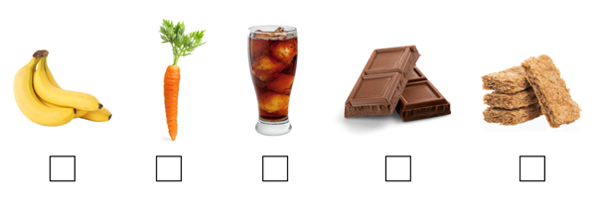
For the final question of this section, the participants were presented with pictures of bananas, a carrot, a cola soft drink, milk chocolate, and wholegrain cereal, and were asked which of these products they thought had a high Health Star Rating (4.5 or 5) (Figure 8).
Figure 8: Survey question relating to Health Star Ratings
The participants were able to choose more than one option. The majority of participants rated carrot (88.7%, n=55), banana (83.9%, n=52) and wholegrain cereal (59.7%, n=37) as the items that had the highest Health Star Rating (Figure 9).

Figure 9: Rating of healthy items

DAILY CONSUMPTION OF FRUITS AND VEGETABLES
In this section of the survey, the participants were asked “On average, how many serves of fruit do you eat each day?”. This was an open-ended question, and the participants could provide any number that would represent their daily consumption of fruits. Almost 60% of participants consumed less than the recommended two serves of fruit per day, with a large proportion (46.8%) having one serve per day (Figure 10).

Figure 10: Daily consumption of fruit
This question was repeated for daily consumption of vegetables, with participants asked: “On average, how many serves of vegetables do you eat each day?”. The participants’ responses were coded in a similar way as the previous question. According to the results, the majority of participants (51.6%, n=32) had one or two daily serves of vegetables (Figure 11).

Figure 11: Daily consumption of vegetables
In conclusion, the results indicated a good awareness of healthy foods and healthy shopping behaviours and attitudes amongst the majority of participants. However, in some areas such as knowledge of the Health Star Rating system, and checking ingredients and health messages, participants’ attitudes could be improved. The results also highlighted that the consumption of fruits and vegetables at the recommended level of least five serves of vegetables and two serves of fruit every day according to the Australian Heart Foundation is not being met by a high percentage of participants, particularly vegetable consumption.0F

4.2 POST-IMPLEMENTATION SURVEY FINDINGS
INTRODUCTION
A post-intervention survey was conducted between October and November 2022. As shown in Figure 12, 75 people completed the post-intervention survey at IGA supermarkets in Morwell, Glengarry and Moe.
Analysis of this survey includes comparison between post- and pre-intervention surveys where that is possible. In addition, the comparison between three sites is provided where appropriate.

Figure 12: Data collection sites
DEMOGRAPHIC INFORMATION
Thirty-four female (45.3%) and thirty-three male participants (44.0%) completed the survey, one participant identified as non-binary and seven chose not to disclose their gender. In the pre-implementation survey the majority of participants were female (69.4%, n=43).
The significant proportion of respondents were aged over 65 years (26.7%, n=20) which is similar to the initial survey. Over half of the respondents had a Health Care Card or Pension Card (53.3%, n=40).
Figure 13: The age range of participants
Participants were asked how often they shopped for groceries, from once a week to less than once a month. Figure 14 below also displays the total number of participants for each site. The majority of participants shopped once a week or more.

Figure 14: Shopping frequency
Health Star Rating System
Participants were asked about their familiarity with the Health Star Rating System. The majority of participants (72.0%, n=54) were familiar with it, and 22.7% (n=17) saying they were not. Four participants (5.3%) did not respond to the question.
The pre-intervention survey showed very similar results: 74.2% (n=46) were familiar with the system and 19.4% (n=12) were not. The results of pre-intervention and post-intervention surveys are presented in Figure 15 below.

Figure 15: Familiarity of participants with Health Star Rating, pre and post-intervention

In regard to the comparison of the three sites in the post-intervention survey, the proportion of participants who were not aware of the Health Star Rating system was slightly higher for Moe and Morwell, as shown in Figure 16.

Figure 16. Familiarity of participants with Health Star Ratings across the three sites
Participants were asked how often they checked the Health Star Rating on a product. The majority of participants (60.0%, n=45) chose the options of “Sometimes”, “Often”, and “Always”. This was slightly lower in comparison to the pre-intervention survey (62.9%, n=39). The results of the participants’ responses across pre-intervention and post-intervention surveys are presented in Figure 17 below.

Figure 17. Frequency of checking Health Star Ratings pre and post-intervention
Across the three sites, as presented in Figure 18, the most popular response to the question about the frequency of checking the Health Star Rating was “Sometimes”. If responses “Sometimes”, “Often” and “Always” are combined together, the results indicate that Glengarry and Moe had a higher percentage of participants (68.8% and 67.9%, respectively), while for Morwell around half of the respondents chose these responses (48.4%). In addition, the response “Rarely” was selected more often in Morwell in comparison with the other two sites.

Figure 18. Frequency of checking Health Star Ratings across the three sites
Participants were asked: “How often does the Health Star Rating influence what you buy?”. The majority of participants (57.4%, n=43), chose the options of “Sometimes”, “Often”, and “Always”. This was slightly lower in comparison with the results of the pre-intervention survey where 69.4% (n=43) of the participants chose the same options. The results are presented in Figure 19 below.

Figure 19. The influence of Health Star Ratings on purchases pre and post-intervention
Across the three sites, as shown in Figure 20, the most popular response to the question about the influence of the Health Star Rating on shopping was “Sometimes” for all sites except Glengarry. If responses “Sometimes”, “Often” and “Always” are combined together, the results indicate that Moe had a higher percentage of participants (67.9%), followed by Glengarry (56.4%), and Morwell (48.4%).

Figure 20: Influence of Health Star Rating on shopping across three sites
Participants were presented with pictures of a banana, carrot, cola soft drink, milk chocolate, and wholegrain cereal, and asked to identify which had a high Health Star Rating (4.5 or 5). The majority of participants rated banana and carrot equally (77.3%, n=58) and wholegrain cereal (62.7%, n=47) as the items that had the highest Health Star Rating. As shown in Figure 21, these results are similar to the results of the pre-intervention survey.

Figure 21: Identifying High Health Star Ratings pre and post-intervention

REACH FOR THE STARS CAMPAIGN MATERIALS
Participants were asked if they had noticed anything that encouraged them to purchase healthier food and drinks while they were shopping. As shown in Figure 22, one in four consumers (24.0%, n=18) had noticed signs or materials, 40.0% (n=30) said that they had not noticed signs or messaging to encourage buying healthier foods and drinks while 33.3% (n=25) were not sure. Glengarry had more “Yes” responses than “No” or “Not sure” in comparison with other sites.

Figure 22. Encouragement to purchase healthier foods all stores

Figure 23. Encouragement to purchase healthier foods by store
Participants in Glengarry, Moe and Morwell who had noticed the Reach for the Stars materials in the store were asked to identify which of the listed promotional materials they saw. 66.7% of participants (n=50) could recall at least one message including “Fruit and vegetable banners/posters”, “Health Star Rating shelf tags”, “Healthy eating messages from Latrobe Stars”, “Healthy recipes”, “Reach for the Stars t-shirts”, and “Reach for the Stars flyer”. Participants could choose more than one option. As shown in Figure 24, the most common answer was “Health Star Rating shelf tags” with 41.3% of respondents (n=31) choosing this option. Five participants did not reply to this question.

Figure 24. Reach for the Stars campaign materials

At each of the individual sites, the Health Star Rating shelf tags were the messages most often recalled by consumers. Refer Figure 25.

Figure 25. Reach for the Stars materials that were noticed at each site
Participants in Glengarry, Moe and Morwell were asked about the impact of Reach for the Stars materials on their thinking about buying healthier foods and on their buying of healthier foods. As shown in Figure 26, the most common answer to the first question was “Yes” with 41.3% (n=31) choosing this option, and “No” was selected by slightly less than one-third of participants (26.7%, n=20). Across three sites with intervention, Moe had a higher proportion with more than half of the participants replying “Yes” (56.6%, n=52), followed by Glengarry (43.7%, n=7) and Morwell (29.0%, n=9).

Figure 26. The impact of Reach for the Star Materials on “thinking” about buying healthier foods
To the question “Did you buy healthier foods as a result of this material?”, the results were the opposite, with more participants who replied “No” (42.7%, n=32) (Figure 27). Only in Moe, did more participants choose “Yes” rather than “No” in comparison with other sites. These results indicate that Reach for Star Materials had an impact on customers’ thinking about buying healthier foods but had not changed their behaviour when buying. However, Moe showed positive results in terms of both questions.

Figure 27. The impact of Reach for the Star Materials on “buying” healthier foods
For those participants who answered “Yes” a follow-up open-ended question asked which materials had the greatest impact and why. Most participants did not answer this question, however, “Bright signage”, “Information on the product”, Advertising” and “Signs” were mentioned.

SHOPPING PATTERNS
In both the pre and post-intervention surveys, participants were asked about the way they shopped. Three statements were given and participants were asked if they agreed or disagreed with each. For reporting purposes, Strongly Agree and Agree have been combined in the positive and Strongly Disagree and Disagree have been combined in the negative. For all three statements, the proportion of participants who agreed in the post-intervention survey was lower than the proportion of participants in the pre-intervention survey (Figure 27).
The first statement was “I find it easy to know which foods are the healthiest when shopping”. As shown in Figure 28 below, the majority of participants in the post-intervention survey (54.7%, n=41) agreed with this statement. However, this proportion was lower in comparison with the pre-intervention survey (66.1%, n=41). Figure 29 shows the differences across the three sites. For all sites, more participants agreed with the statement, however, there were significant differences between each site.

Figure 28. Knowledge of healthy foods – all sites – pre and post-intervention

Figure 29. Knowledge of healthy foods – individual sites
The statement, “I always choose the healthiest products available when shopping” saw more people in the pre-intervention survey who agreed (54.8%, n=34) than in the post-intervention survey (40.0%, n=30) (Figure 30). As shown in Figure 31, the majority of participants at all sites agreed with the statement.

Figure 30. Choosing healthy foods at all sites, pre and post-intervention

Figure 31. Choosing healthy foods – individual sites

The responses to the statement, “Before buying any food or drink, I always look at the Health Star Rating”, were similar to the first two statements, a lower number agreed in the post-intervention survey (30.7%, n=23) in comparison with the pre-intervention survey (38.7%, n=24) (Figure 32). Across three sites, the results are inconsistent showing more participants disagreed with the statement in Glengarry, more neutral in Moe and more agreed in Morwell (Figure 33).

Figure 32: Checking health star ratings – all sites – pre and post-intervention

Figure 33. Checking health star ratings at individual sites
The survey asked if participants were more or less likely to shop at this particular store because of the Reach for the Stars campaign. A large proportion of participants chose “More likely” (48.0%, n=36), followed by “no change” (45.3%, n=34) and 2.7% (n=2) were “less likely”. The majority of participants (61.3%, n=46) had not heard about the campaign prior to their visit. Figure 34 below shows the responses to this question for each site.

Figure 34. Responses to “Had you heard about Reach for the Stars?”
Those who had previously heard about the campaign were asked where they received this information. Of the 23 (36.6%) of participants who responded to this question, as shown in Figure 35 below, the most common answer was through visiting the store (18.7%, n=14).

Figure 35. Source of information about the campaign

STRATEGIES FOR SUPERMARKETS
The last section of the post-intervention survey included questions about the strategies that could be used by stores to encourage customers to buy more healthy foods. The majority of participants (89.3%, n=67) agreed they should continue to encourage healthy eating. In the following question with five statements, participants were asked if they agreed or disagreed with each. For reporting purposes, Strongly Agree and Agree have been combined in the positive and Strongly Disagree and Disagree have been combined in the negative throughout this report.
As shown in Figure 36 below, at all three sites, participants agreed that stores should have at least one checkout that did not display unhealthy foods.

Figure 36. Display of foods at checkouts
However, fewer participants agreed that there should be no checkouts that display unhealthy foods as shown in Figure 37 below. The responses varied across the sites.

Figure 37: Display of unhealthy foods
The majority of participants at all sites also agreed that the displays at the end of supermarket aisles should display healthier foods (Figure 38).

Figure 38: Display of healthier products at the end of aisles
The majority of participants agreed that supermarkets should offer price discounts on healthy foods (Figure 39).

Figure 39: Price discounts on healthy foods

The majority of participants at all sites agreed with the statement “Supermarkets should have more shelf space for healthy foods” (Figure 40).

Figure 40: Shelf space for healthy foods
When asked for suggestions as to how the campaign could be improved, seven participants commented. Australian branding was important to two participants, with another wanting more advertising of healthy foods and making sure they were within people’s price range. For one participant, the stars could be bigger, and for two others the campaign was seen as positive and should continue.

SUMMARY AND CONCLUSION
Overall, compared to the results of the pre-intervention survey, a statistically significant improvement in the outcomes of interest was not demonstrated. Potentially, this could be due to the participants’ prior awareness of the health rating star system and their awareness of healthy shopping behaviours. When asked directly about the perceived impact of the campaign, the results confirmed the effectiveness of the campaign in improving further awareness towards healthier shopping behaviours. The vast majority of participants suggested that these campaigns should continue, and it could be associated with other changes in supermarkets such as price discounts and more shelf space for healthy foods.
In addition, there are no significant differences across the three sites. Only for one question about the influence of Reach for Star Materials on customers’ thinking about buying healthier foods and their existing shopping patterns, Moe showed better positive results in comparison with the other two sites.
Unintended findings
The post-intervention survey highlighted a consistent difference between the Morwell site and the others, with Morwell figures indicating lower health literacy. For example, the number of respondents who answered ‘yes’ when asked if they were familiar with health star ratings was over 20% lower for the Morwell (64.5%) site than Glengarry (87.5%).

4.3 MONASH UNIVERSITY STORE SCOUT
The Store Scout was a mobile application (app) that enables the rapid appraisal of store customer food environment (retail choice architecture) using the 4 Ps of marketing which are product availability, placement, promotion and price across seven categories of food and drinks:
- Fruit and vegetables
- Drinks
- Snacks
- Meals and convenience foods
- Breads and cereals
- Dairy products
- Eggs, meat, seafood
When an assessment was completed using the app, an overall practice score was generated. A previous study reported that the Store Scout mobile app demonstrated good inter-rater reliability of measurement items and internal consistency. Using the Store Scout mobile app, two experienced evaluators independently assessed the above categories.
A pre-intervention appraisal was completed for IGA Moe on the 8th August 2022 and the 15th August 2022 for both IGA Glengarry and IGA Morwell. The Reach for the Stars intervention was implemented in IGA Moe from the 8th of August 2022 until the 2nd of October 2022. The intervention was also implemented in IGA Glengarry and IGA Morwell from the 22nd of August 2022 until the 16th of October 2022. The eight-week intervention comprised a variety of promotional material designed to encourage healthy food options. The Moe, Glengarry and Morwell stores were each appraised twice during the intervention. Although the appraisals occurred during the intervention period, this analysis will refer to these scores as ‘post-intervention’. Table 1 displays the overall Store Scout average results for the three stores.
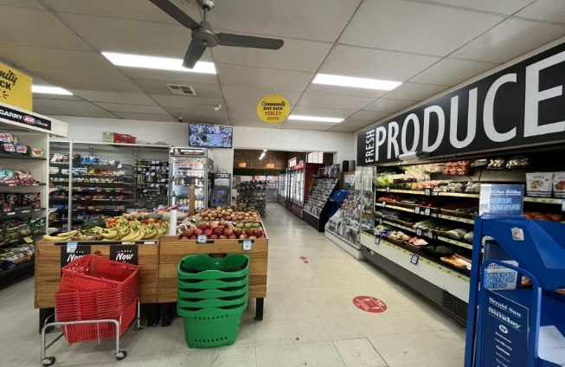
The eight-week intervention comprised a variety of promotional material designed to encourage healthy food options as illustrated in Figure 41a and Figure 41b.
Figure 41a: Pre implementation photos highlighting Reach for the Stars messaging.
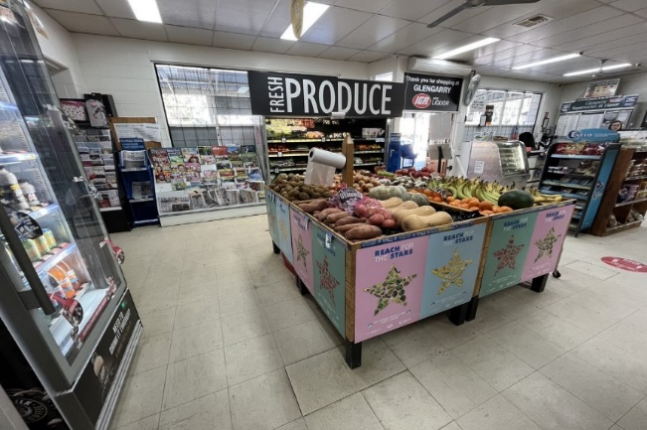
Figure 41b: Post implementation photos highlighting Reach for the Stars messaging.

Table 1 demonstrates that the overall healthiness of the food retail environment at the three IGA sites increased by 3.7%. The areas showing the greatest improvement were in the food categories of breads and cereals, fruit and vegetables, and promotion.
Description | Pre-Intervention (n=3) Scores (%) | Post-Intervention (n=6) Scores (%) | Variance (%)
Overall Score | 60.0 | 63.7 | + 3.7
Product | 55.3 | 61.3 | + 6.0
Placement | 56.7 | 58.7 | + 2.0
Price | 46.0 | 53.0 | + 7.0
Promotion | 44.3 | 39.8 | - 4.5
Fruits & Vegetables | 86.3 | 93.5 | + 7.2
Drinks | 58.7 | 46.2 | - 12.5
Snack Foods | 27.7 | 33.3 | + 5.6
Meals/Convenience Foods | 45.3 | 51.5 | + 6.2
Breads & Cereals | 77.7 | 84.2 | + 6.5
Meat & Seafood | 49.7 | 58.0 | + 8.3
Dairy & Eggs | 74.0 | 79.2 | + 5.2
Table 1: Store Scout Summary – Pre and Post Intervention

Product and placement experienced a decline although this was not uniform across all sites, refer to figures below highlighting individual store results.

IGA 1

Figure 41: IGA1 - Store Scout Comparison at each Post-Intervention Appraisal
At IGA1 there was demonstrated improvement post-implementation in price and promotion. There was also an increase in fruit and vegetables, breads and cereals, and dairy and eggs. There was a spike in meals/convenience foods which occurred during the second appraisal (6/9/2022). Possible causes include external promotions unrelated to the Reach for the Stars project, or perceived time constraints, such as participation in or watching football finals, encouraging customers to buy ready-made meals. Product and placement decreased from pre-intervention.
The overall score for IGA1 remained similar across the evaluation period; 58 (pre-intervention) and 60 at the final appraisal (12/9/2022).

Figure 43: IGA1 - Comparison with Benchmark Supermarkets
The graph above compares IGA1 to two larger benchmark supermarkets. While the overall score remained lower, post-intervention results for IGA1 was equal to or above benchmark supermarkets in the areas of placement, price and promotion, and in the food categories of fruit and vegetables, drinks, breads and cereals, and dairy and eggs.

IGA 2

Figure 24: IGA2 - Store Scout Comparison at each Post-Intervention Appraisal
Results for IGA2 (Figure 44) showed continued improvement across the three post-intervention appraisals for fruit and vegetables and breads and cereals. Snack foods remained steady throughout the evaluation period. There was a noticeable decrease in price at the initial post-implementation appraisal (15/8/2022) when compared to other appraisals.
The overall score at IGA2 increased from 57 (pre-intervention) to 64 at the final appraisal in September 2022, with a score of 67 achieved at the second appraisal (23/8/2022).

Figure 43: IGA2 – Comparison with Benchmark Supermarkets
The graph above compares IGA2 to data from two larger benchmark supermarkets. Post-intervention results for IGA2 were similar to the benchmark supermarkets including the overall score, placement, and promotion and in the food categories of fruit and vegetables, drinks, breads and cereals, and dairy and eggs. Price was below the benchmarks which may be due to the more remote location of the site incurring additional transportation costs and challenging supply chain issues.

IGA 3

Figure 44: IGA3 - Store Scout Comparison at each Post-Intervention Appraisal
IGA3 recorded significant improvement for fruit and vegetables, meals/convenience foods and breads and cereals (Figure 46). Promotion recorded a significant improvement in two post-intervention appraisals (15/8/2022 and 23/8/2022).
The overall Store Scout score at IGA3 increased from 55 (pre-intervention) to 63 at the final post-intervention appraisal.

Figure 45: IGA3 - Comparison with Benchmark Supermarkets
The graph above compares IGA3 to data from two larger benchmark supermarkets. The overall post-intervention score for this supermarket increased to be in line with the benchmarks, a pleasing result. All areas with the exception of product were equal to or better than one or both of the larger supermarkets in the post-intervention appraisal.

Comparative Store Data
Comparative Store Analysis | IGA1 | IGA2 | IGA3 | Benchmark 1 | Benchmark 2
Overall Score | 61 | 65.5 | 64.5 | 65.0 | 67.0
Product | 58 | 64 | 62 | 73.0 | 74.0
Placement | 56 | 58.5 | 61.5 | 57.0 | 53.0
Price | 53.5 | 53.5 | 52 | 52.0 | 59.0
Promotion | 47 | 40 | 32.5 | 30.0 | 39.0
Fruits & Vegetables | 92 | 95.5 | 93 | 89.0 | 86.0
Drinks | 45 | 46.5 | 47 | 49.0 | 45.0
Snack Foods | 34 | 32.5 | 33.5 | 40.0 | 37.0
Meals/Convenience Foods | 50 | 48.5 | 56 | 62.0 | 46.0
Breads & Cereals | 75 | 87.5 | 90 | 71.0 | 88.0
Meat & Seafood | 49.5 | 65.5 | 59 | 70.0 | 78.0
Dairy & Eggs | 84 | 81 | 72.5 | 71.0 | 87.0
Table 2: Comparative store data
Table 2 outlines the overall Store Scout score comparison between IGA stores and benchmark supermarkets in the data collection period. IGA2 and IGA3 performed closely to the larger benchmark 1 supermarket, while IGA1 had the lowest overall score. In some areas of comparison such as placement, IGA3 outperformed the benchmark supermarkets, while IGA1 and IGA2 were in line with benchmark scores. IGA3 also outperformed the benchmark stores in individual items such as fruits and vegetables, and breads and cereals. While IGA1 outperformed the benchmark stores in drinks. Analysis of promotion was highest in IGA1, outperforming the other IGA stores and the benchmark stores.

Limitations of Store Scout App
In a commercial business such as a supermarket, a number of competing interests may impact outcomes. Store scout assessments may have been influenced by external factors unrelated to the project such as availability of products and produce, post-COVID supply chain issues, limited fresh food increased cost and decreased availability due to environmental factors including floods, droughts and bushfires. Assessments were completed by different students which may also have impacted Store Scout results. Smaller retailers such as those that participate in the project may also have less reliable supply chains due to lower volumes and less regular deliveries.

4.4 INTERVIEWS WITH STORE MANAGERS

Store managers were invited to participate in an individual interview to share their insights into the Reach for the Stars campaign. The store managers, however, declined the invitations to participate in this evaluation.

4.5 STAKEHOLDER FOCUS GROUP

A focus group involving three key project stakeholders’ representatives was conducted on the 12th of April 2023 at the LCHS office in Morwell. The participants from the LHA and LCHS had been actively involved with the project from conceptualisation and project design through to implementation and evaluation. Three members of the CERC team were present during this semi-structured interview, which lasted for 28 minutes. The interview questions were developed iteratively prior to the interview and consisted of the following questions:

- How do you think the project went?
- What are the lessons learnt from this project?
- How do you see this project affecting behaviour change within the community?
- What would you like to happen in the future?
- What would you do differently, knowing what you know now?
- What advice would you have for another healthcare organisation or service who are going to commit to a similar campaign?

The focus group was audio-recorded and transcribed verbatim. A content analysis of the transcripts was conducted and presented as a narrative synthesis. Four themes resulted and are presented; The impact of collaboration; Creating a balance; Lessons learnt for sustainability; and Moving healthy eating forward.

The impact of collaboration

Collaboration was acknowledged to be the key to the success of the project. Collaboration occurred in many forms, including in the partnership between LCHS and LHA and community consultation. It was acknowledged that the Reach for the Stars campaign was a ‘flagship project’ and the first of its kind to directly target a large food retail outlet, supermarkets, to encourage healthier eating. The collaboration between the LCHS and LHA was recognised as an important step forward for this project and for future projects. It was acknowledged that the campaign could not have been implemented without the partnership model which benefited from the project team members individual strengths. The project also built capacity within the team.

“I think that's been really beneficial because not only has it raised the skill sets within the teams, but it's also given the project far more depth and breadth across the community as well.”

Community consultations and co-design strategies were considered an important element of the project. One participant reflected,

“I think it was really successful that we had such community involvement in the planning and design of the project. So you could say it was for Latrobe residents, by Latrobe residents.”

The participants agreed that the community ‘buy-in’ was an important part of the design process, which also extended to commitment from the organisation’s executive level. This successful buy-in from the ground level up to the executive level has inspired the possibility of future collaborations for health campaigns.

“I think the partnership has really extended what we can potentially do in the future as well because of this project.”

Creating a balance

The Reach for the Stars project was considered to be an important contribution for public health, particularly from a health equity perspective. The campaign was intended to promote healthier eating options for all community members. The participants considered the conceptualisation phase to be an inclusive process,

“In the co-design, we worked with priority populations, so those from a more disadvantaged background.”

This was an important consideration given that the three stores are situated in lower socioeconomic indexes for areas (SEIFA) towns. The participants discussed the importance of providing health education and creating a balance for customers.

“We're trying to not fight back against the other marketing that exists in the store, but also make sure that there's some equality or some balance within a store so that you're not just bombarded with unhealthy marketing.”

This campaign aimed to facilitate a seamless shopping experience for the customer and encourage them to select healthier foods.

Lessons learnt for sustainability

The participants reflected on the barriers they encountered during the project. One particular observation was the need to develop a relationship with supermarket owners/managers, mostly around time and deadlines. As one participant noted,

“We definitely had to have flexibility because they are incredibly busy running their stores, doing those day-to-day operations, so …we need to work with their time that they had available.”

Although collaboration was an important part of the design stage, the participants acknowledged that the Reach for the Stars campaign would have benefitted more from the supermarket owners’ input.

“It would have been valuable to have an even stronger relationship at this point in time, and potentially they had other perspectives that weren't necessarily considered or explored to their full potential.”

Additional input from supermarket owners or their regional co-ordinators may have facilitated a seamless transition during the implementation phase. This was agreed by another participant, who noted, “If we're doing something in the supermarket, they need to have ownership of that to make sure it's maintained long term.” Further suggestions from the participants included the need to gain the perspectives of retail assistants, given their close contact with customers. Overall, the participants were complimentary about the contribution by the supermarket owners and their commitment to the campaign. Furthermore, the need for adequate time and resources, especially a longer pilot time was highlighted as paramount to the sustainability of the program.

Moving healthy eating forward

Ideas for progressing the Reach for the Stars campaign was discussed by the participants. Using a ‘blue-sky thinking’ approach, one participant reflected on the potential of the campaign to impact the public on a national level.

“I would love to see this in all supermarkets everywhere. I would love to see the health star rating mandatory for all packaged foods in Australia. If the Health Star Rating system was mandatory for all foods, we actually wouldn't need a campaign like this.”

For the participants the advantage of the campaign was that it built upon existing knowledge within the community and was informed by evidence-based practice. The Reach for the Stars campaign provided an educational component, as well as simplifying the process of identifying healthy food options.

“I would hope that this is providing all the community members with education about what healthy foods are and just makes it really easy for customers to be able to find healthy foods in the supermarket when they're doing their shopping.”

The participants acknowledged the continuation of the project would benefit the community, however this would require further work in developing and investing in relationships with supermarket owners.

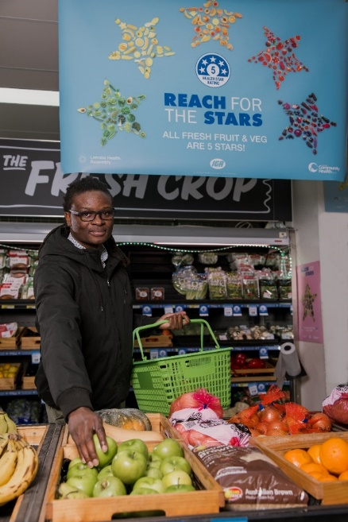

Image: Campaign promotional image

5. DISCUSSION AND RECOMMENDATIONS

5.1 DISCUSSION
This discussion will look at each of the research questions, and from the discussion and project findings recommendations will be proposed.
1. Did shoppers notice the campaign messaging?
The post-intervention survey conducted showed that 76.5% of participants either did not notice the campaign messaging or were not sure that they had. However, for consumers who did remember seeing the campaign in-store, 66.7% were able to recall accurately at least one of the messages.

2. If so, what elements of it (e.g. posters, shelf labels etc.) did they notice?
For those who did notice, it was the Health Star Rating shelf tags that were most popular (25.0%), followed by fruit and vegetable banners and posters (16.1%). Bright signage was also mentioned. Only 6.5% of consumers could recall seeing a Reach for the Stars flyer, with 8.1% mentioning the healthy messages from Latrobe Stars and a similar number recalling Reach for the Stars t-shirts. There were consumers (14.5%) who mentioned the healthy recipes.

3. Did these campaign elements change the way they think or feel towards healthier eating?
There was a positive the change in the way participants felt about healthier eating attributed as an impact of the Reach for the Stars materials. The majority of the participants also indicated that they knew what was healthy, and as such, the Reach for the Stars materials did not further their knowledge about the rating of foods. There was, however, several times that the importance of the need to increase awareness and rating was deemed to be worthy of further implementation and exploration.

4. Did these campaign elements change actual behaviour (as measured by the increased purchase of healthier foods)?
The positive change of feeling towards healthier eating did not translate in to a change of behaviour when making purchases in two out of the three sites. Participants also agreed that these types of campaigns should continue. From the results it can be concluded that the campaign improved awareness of healthier food, and though it did not translate into a change in behaviour, there was a strong possiblity that a lengthier campign that encompassed a broad number of points of sale would lead to change. For example, in larger supermarkets, smaller ‘milk bars’, and in school canteens. With regards to measuring the increase in purchasing of healthier foods, data supplied was insufficient to draw conclusions. The data suggested that literacy around Health Star Ratings was consistently lower in the Morwell store, and this could be a consideration for future campaigns with the possiblity of targetting a specific area to increase literacy.

5. What insights can staff and managers provide into the success and impact of the Campaign?
The store staff and managers declined the invitation to participate in an interview. Therefore, no insights were collected.

6. What perceived benefits were there to the supermarket in participating in the Campaign?
It was not possible to see any direct benefits to the supermarkets as measured in store item sales as the length of the intervention and the complexity of the store data made it difficult to make direct correlations with impact of Reach for the Stars materials. Indirectly, stores benefited from participating in a community social equity project that promoted healthy shopping habits and behaviours.

Information provided by LCHS notes that the project has included an estimated promotional reach of more than one million people, including participating supermarkets. This information has not been verified by CERC.

7. Would the supermarket participate in such a Campaign if it were to run again in the future? If so, what aspects of the Campaign worked well, and what aspects could be improved?
It was not possible to answer whether supermarkets would participate in such a campaign in the future without directly speaking with store managers and staff. The incentives offered were not substantial enough to warrant full involvement of store managers in the program, as there was difficulty contacting them, a general reluctance to be interviews, and constraints in accessing complex store data. It was possible that alternative incentives may have encouraged other supermarkets, including larger stores, to participate. For the managers and staff the issue of being able to find time to spend being interviewed was highlighted.

8.What other strategies might supermarkets use to encourage healthier diets amongst their customer base?
The strategies that supermarkets can use to encourage healthier diets amongst their customer base that respondents agreed most to are by offering price discounts on healthy foods and allocating more shelf space for healthy foods. Respondents also agreed with displaying healthier products at the end of aisles and having at least one checkout that does not display unhealthy foods. While healthy recipes were included as part of messaging consumer recall of these was quite low (24%). The inclusion of meal recipes in addition to meal packages were identified as possible strategies to increase the purchasing of healthy food options.

Further discussion and planning are needed to explore ways to further encourage healthier diets for regional communities.

Co-design and relationships
The relationship with store owners was highlighted as being crucial to a campaign of this type. The collaborative approach that included members of the community worked well in the design of the campaign, however, the involvement of store owners and or senior staff would have been of benefit.

Effectiveness of the Store Scout App
The Store Scout App provided useful data on the 4 Ps of marketing, product availability, placement, promotion and price promotion and has great potential to be used in future campaigns. The collection of data using the app needs close coordination between different stores and times of data collection, as well as continuity of people collecting the data.

5.2 RECOMMENDATIONS
From the analysis of the collected data the following recommendations are made:
- The campaign is worthy of continuing as it influences customer thinking about healthier foods.
  - A longer and broader campaign is needed to establish a sustainable change in customer behaviour.
  - Visibility of Reach for the Stars materials remains present.
- Change the Health Star Rating threshold to 4 stars and above which will decrease confusion for consumers and include more ‘core’ food products including pastas, breads, and eggs.
- The co-design process should include store managers and all staff to ensure they support the concept of the campaign.
  - Encourage customers to help design resources, recipes, and promotional items to ensure the campaign is relatable to the target population.
  - Provide opportunities for enhancement of the intervention phase which may include incentives.
- Explore other healthy retail strategies such as ensuring healthy options are within consumer’s price range and promoting branding highlighting Australian grown produce.
- Incentivise supermarkets to participate in future healthy options campaigns.
- Measuring impact of the Reach for the Stars intervention requires a longitudinal methodology which incorporates the ability to extract store data of individual items.
  - A targeted approach to extraction of store data with the focus on fresh fruit and vegetables and easily identifiable items in the store data codes.

6. LIMITATIONS

There were limitations related to this evaluation that must be considered. These include:
- The unavailability of store managers and staff for interviews.
- The extended delays for the extraction of store data and the complex nature of the store data inhibited the ability to analyse the data.
- The pre survey participants were different from the post survey participants making it only possible to compare cohorts and not individuals. Longitudinal data collection would elicit more reliable data to measure changes in behaviour.
External factors including the impact of inflation, cost of living pressures and rising cost of fresh fruit and vegetables as a result of environmental factors (floods, bushfires) may have influenced consumer capacity to fully embrace the campaign. Despite these limitations, the evaluation is considered to present a credible assessment of the project.

7. ETHICAL APPROVAL AND PRACTICE

Federation University aims to promote and support responsible research practices by providing resources and guidance to our researchers. We aim to maintain a strong research culture which incorporates:
- Honesty and integrity;
- Respect for human research participants, animals and the environment;
- Respect for the resources used to conduct research;
- Appropriate acknowledgement of contributors to research; and
- Responsible communication of research findings.
Human Research and Ethics applications, Evaluating the “Eat Well @ IGA” campaign, was approved by Federation University Human Research Ethics Committee prior to data collection and analysis (A22-031).

8. ABBREVIATIONS

CERC Collaborative Evaluation & Research Centre
LCHS Latrobe Community Health Service
LHA Latrobe Health Assembly
SEIFA Socioeconomic Indexes for Areas

9. LIST OF FIGURES AND TABLES
FIGURES
Figure 1: Data collected … 15
Figure 2: Number of participants from each store … 16
Figure 3: The age range of participants … 16
Figure 4: Importance of various features when purchasing grocery items … 17
Figure 5: Shopping patterns … 17
Figure 6: Frequency of checking Health Star Ratings … 19
Figure 7: Frequency of purchasing due to Health Star Ratings … 19
Figure 8: Survey question relating to Health Star Ratings … 19
Figure 9: Rating of healthy items … 20
Figure 10: Daily consumption of fruit … 20
Figure 11: Daily consumption of vegetables … 21
Figure 12: Data collection sites … 22
Figure 13: The age range of participants … 22
Figure 14: Shopping frequency … 23
Figure 15: Familiarity of participants with Health Star Rating, pre and post intervention … 24
Figure 16: Familiarity of Participants with Health Star Ratings across the three sites … 24
Figure 17: Frequency of checking Health Star Ratings, pre and post intervention … 25
Figure 18: Frequency of checking Health Star Ratings across the three sites … 25
Figure 19: The influence of Health Star Ratings on purchases, pre and post intervention … 26
Figure 20: Influence of Health Star Rating on shopping across three sites … 26
Figure 21: Identifying Health Star Ratings pre and post intervention … 27
Figure 22: Encouragement to purchase healthier foods all stores … 27
Figure 23: Encouragement to purchase healthier foods by store … 28
Figure 24: Reach for the Stars campaign materials … 28
Figure 25: Reach for the Stars materials that were noticed at each site … 29
Figure 26: The impact of Reach for the Stars on “thinking” about buying healthier foods … 30
Figure 27: The impact of Reach for the Stars on “buying” healthier foods … 30
Figure 28: Knowledge of healthy foods – all sites – pre and post intervention … 31
Figure 29: Knowledge of healthy foods – individual sites … 31
Figure 30: Choosing healthy foods at all sites, pre and post intervention … 32
Figure 31: Choosing health foods – individual sites … 32
Figure 32: Checking Health star Ratings – all sites – pre and post intervention … 33
Figure 33: Checking Health Star Ratings at individual sites … 33
Figure 34: Responses to ”Have you heard about Reach for the Stars?” … 34
Figure 35: Source of information about the campaign … 34
Figure 36: Display of foods at checkouts … 35
Figure 37: Display of unhealthy foods … 35
Figure 38: Display of healthier products at ends of aisles … 36
Figure 39: Price discounts on healthy foods … 36
Figure 40: Shelf space for health foods … 37
Figure 41a: Pre implementation photos highlighting Reach for the Stars messaging … 39
Figure 41b: Post implementation photos highlighting Reach for the Stars messaging … 39
Figure 46: IGA1 - Store Scout Comparison at each Post-Intervention Appraisal … 40
Figure 43: IGA1 - Comparison with Benchmark Supermarkets … 41
Figure 74: IGA2 - Store Scout Comparison at each Post-Intervention Appraisal … 41
Figure 48: IGA2 - Comparison with Benchmark Supermarkets … 42
Figure 49: IGA3 - Store Scout Comparison at each Post-Intervention Appraisal … 43
Figure 410: IGA3 - Comparison with Benchmark Supermarkets … 43

TABLES
Table 1: Store Scout Summary – Pre and Post Intervention … 40
Table 2: Comparative store data … 44

10. APPENDICES

10.1 CUSTOMER INTERVIEWS
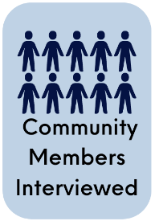
Customers who completed surveys during October 2022 at stores taking part in the Reach for the Stars campaign were asked to if they would like to be interviewed. Ten participants agreed to be interviewed as part of the project evaluation. All interviewees stated that they were the person responsible for grocery shopping in their household.

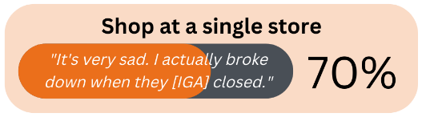
A total of seven participants said that they completed all of their grocery shopping at a single store, while the remaining three interviewees shopped at more than one store. The main reason provided for shopping at more than one store was “because they don’t all have the same stock.” The main reasons provided by interviewees for selecting to use a single store was “the products”, “continuity”, and “better service”.

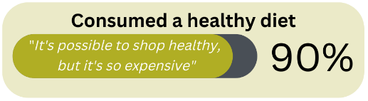
A total 90% of the participants identified that they consumed a healthy, or relatively healthy diet. When asked to describe what food they normally ate, the most popular response was “fruit, veggies, meat.” The concept of a balance diet was mentioned by a number of participants, and different perspectives of balance were mentioned, from balancing the number of nights that pasta, rice and vegetables are eaten, or balancing the amount of processed food in the trolley at the time of purchase.

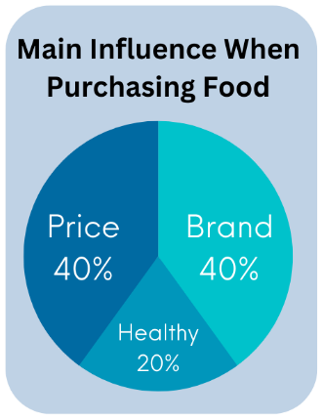
Participants identified that most important thing when purchasing food were price and brand, with 40% stating one or the other. The perception of food as healthy was the lowest priority. When discussing brand, interviewees identified “I tend to stick to products that I know I'm comfortable with”, this included the ingredients in the products.

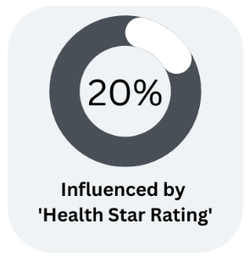
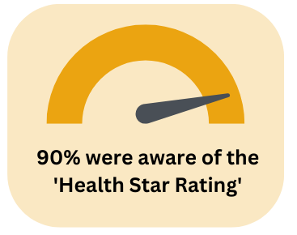
A total of 9 in 10 participants were aware of Health Star Ratings, however only two interviewees stated that it would influence their purchase. “I don’t take notice of it” was the most common response provided by participants. Another common response was “I know what’s healthy”. Most participants were more likely to review the ingredients of the product to decide if it was healthy; “I always look at the ingredients, how much salt, fats and sugars, I don’t take much notice of a star rating”. Price was a topic of discussion by participants, noting ‘you can't afford to do a big healthy shop sometimes’.

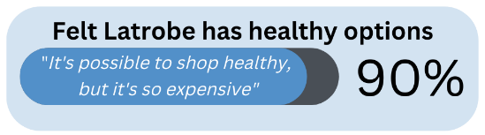
The majority of participants felt that there were healthy food options available in Latrobe City with Traralgon being perceived as the town with the healthiest food options available. Affordability was said to be the main barrier to purchasing healthy foods; “It’s a lot cheaper to go to McDonalds”.

Image: Campaign promotional image
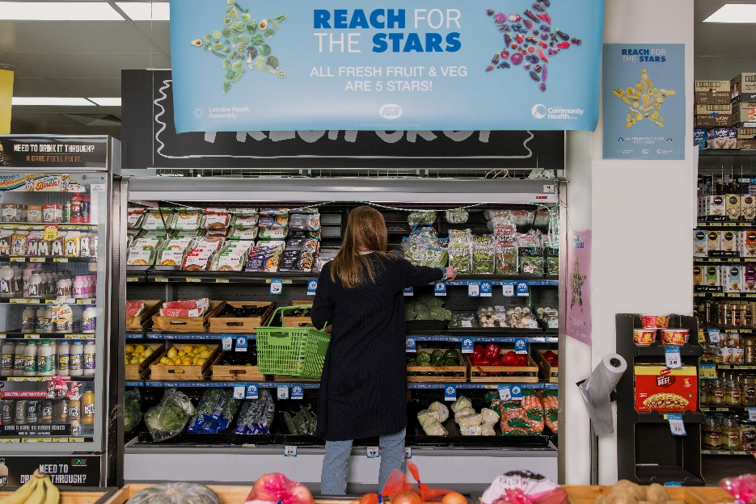

10.2 HUMAN RESEARCH AND ETHICS APPROVAL
Principal Researcher: | Associate Professor Joanne Porter
Co-Researcher/s: | Valerie Prokopiv  Dr Vaughan Reimers
School/Section: | School of Health
Project Number: | A22-031
Project Title: | Evaluating the “Eat Well @ IGA” campaign.
For the period: | 21/04/2022 to 21/04/2027 (standard 5-year project approval has been introduced)
Quote the Project No: A22-031 in all correspondence regarding this application.

Approval has been granted to undertake this project in accordance with the proposal submitted for the period listed above.

Please note: It is the responsibility of the Principal Researcher to ensure the Ethics Office is contacted immediately regarding any proposed change or any serious or unexpected adverse effect on participants during the life of this project.

In Addition: Maintaining Ethics Approval is contingent upon adherence to all Standard Conditions of Approval as listed on the final page of this notification.

COMPLIANCE REPORTING DATES TO HREC:

Annual project report:
21 April 2023
21 April 2024
21 April 2025
21 April 2026
Final project report:
21 May 2027
A final report must be submitted within six months of the project completion, which may be prior to the date noted above. Submission of a final report will close off the project.
The combined annual/final report template is available at:
HREC Forms

Fiona Koop
Coordinator, Research Ethics
21 April 2022



Office 1E219 | Building 1E | Gippsland Campus
PO Box 3191 Gippsland Mail Centre Vic 3841
T 03 5122 6508 M 0412 142 055
CERC@federation.edu.au

CRICOS Provider No. 00103D | RTO Code 4909
Federation University Australia acknowledges the Traditional Custodians of the lands and waters where its campuses are located, and we pay our respects to Elders past and present, and extend our respect to all Aboriginal and Torres Strait Islander and First Nations Peoples.

AIHW Overweight and Obesity Web Report, 19 May 2023, accessed 12 July 2023, https://www.aihw.gov.au/reports/overweight-obesity/overweight-and-obesity/data
Victorian Population Health Survey (2018), accessed 11 July 2023, https://vahi.vic.gov.au/reports/population-health/victorian-population-health-survey-2018-summary-results
Victorian Department of Health – Leading Causes of Disease and Injury, accessed 11 July 2023, https://www.health.vic.gov.au/your-health-report-of-the-chief-health-officer-victoria-2018/burden-of-disease/leading-causes-of
Blake MR, Sacks G, Zorbas C, Marshall J, Orellana L, Brown AK, Moodie M, Ni Mhurchu C, Ananthapavan J, Etilé F, Cameron AJ. The 'Eat Well @ IGA' healthy supermarket randomised controlled trial: process evaluation. Int J Behav Nutr Phys Act. 2021 Mar 12;18(1):36. doi: 10.1186/s12966-021-01104-z. PMID: 33712022; PMCID: PMC7953771.
Heart Foundation: Fruit, vegetables and heart health: https://www.heartfoundation.org.au/bundles/healthy-living-and-eating/fruit-vegetables-and-heart-health
McMahon E, Jaenke R, Brimblecombe J. A Mobile App to Rapidly Appraise the In-Store Food Environment: Reliability, Utility, and Construct Validity Study JMIR Mhealth Uhealth 2020;8(7):e16971 DOI: 10.2196/16971

